THE PARTS BOOK OF NS-1508AE-D MACHINE
EDGE WRAPPING PART
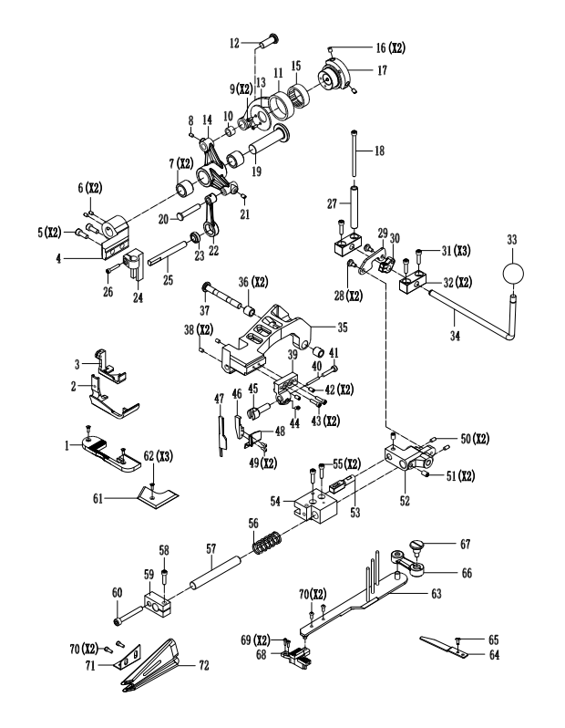

Fig.No. | Part No. | Description | Pcs.
1 | 28-1001 | NEEDLE PLATE | 1
 |  | NEEDLE PLATE SCREW | 2
2 | 28-1002 | PRESSER FOOT | 1
3 | 28-1003 | INNER PRESSER FOOT | 1
4 | 28-1004 | CRANK BRACKET | 1
5 | 28-1005 | CRANK BRACKET SCREW | 2
6 | 28-1006 | LINK SHAFT SET SCREW | 2
7 | 28-1007 | LINK SHAFT CRANK BUSHING | 2
8 | 28-1008 | LINK SHAFT CRANK SCREW | 1
9 | 28-1009 | COVER PLATE SCREW | 2
10 | 28-1010 | NEEDLE BEARING | 1
11 | 28-1011 | LINK LEVER | 1
12 | 28-1012 | LINK LEVER PIN | 1
13 | 28-1013 | COVER PLATE | 1
14 | 28-1014 | LINK SHAFT CRANK | 1
15 | 28-1015 | NEEDLE BEARING | 2
16 | 28-1016 | SET SCREW | 2
17 | 28-1017 | ECCENTRIC GEAR | 1
18 | 28-1018 | TAPE GUIDE SHAFT SCREW | 1
19 | 28-1019 | LINKING SHAFT | 1
20 | 28-1020 | LINKING LEVER PIN | 1
21 | 28-1021 | SETTING SCREW | 1
22 | 28-1022 | LINKING LEVER | 1
23 | 28-1023 | RADIAL BEARING | 1
24 | 28-1024 | GUIDE BRACTET | 1
25 | 28-1025 | GUIDE BRACTET SHAFT | 1
26 | 28-1026 | GUIDE BRACKET SCREW | 1
27 | 28-1027 | TAPE GUIDE SHAFT | 1
28 | 28-1028 | PULLING PLATE SCREW | 2
29 | 28-1029 | PULLING PLATE | 1
30 | 28-1030 | PULLING PLATE CRANK | 1
31 | 28-1031 | FIX BLOCK SCREW | 3
32 | 28-1032 | FIX BLOCK | 2
33 | 28-1033 | HAND LEVER BALL | 1
34 | 28-1034 | HAND LEVER | 1
35 | 28-1035 | MAIN BRACKET | 1
36 | 28-1036 | MAIN BRACKET BUSHING | 2
37 | 28-1037 | LINKING SHAFT | 1
38 | 28-1038 | SCREW | 2
39 | 28-1039 | SETTING BRACKET | 1
40 | 28-1040 | INNER PIN | 1
41 | 28-1041 | INNER PIN SCREW | 1
42 | 28-1042 | ADJUSTING SCREW | 2
43 | 28-1043 | SETTING BRACKET SCREW | 2
44 | 28-1044 | BLADE BRACKET SETTING SCREW | 1
45 | 28-1045 | BLADE BRACKET | 1
46 | 28-1046 | PROTECT COVER SETTING BRACKET | 1
47 | 28-1047 | BLADE | 1
48 | 28-1048 | PROTECT COVER | 1
49 | 28-1049 | PROTECT COVER SCREW | 2
50 | 28-1050 | SETING SCREW | 2
51 | 28-1051 | SETTING SCREW | 2
52 | 28-1052 | MAIN BRACKT LINK BASE | 1
53 | 28-1053 | LINK BASE PIN | 1
54 | 28-1054 | SETING BLOCK | 1
55 | 28-1055 | SETTING BLOCK SCREW | 2
56 | 28-1056 | SPRING | 1
57 | 28-1057 | GUIDE SHAFT | 1
58 | 28-1058 | SETTING BLOCK SCREW | 1
59 | 28-1059 | GUIDE SHAFT SETTING BLOCK | 1
60 | 28-1060 | STOP SCREW | 1
61 | 28-1061 | FRONT PLATE | 1
62 | 28-1062 | FRONT PLATE SCREW | 3
63 | 28-1063 | BINDER SUPPORT | 1
64 | 28-1064 | SETTING PLATE | 1
65 | 28-1065 | SETTING PLATE SCREW | 1
66 | 28-1066 | LINK LEVER | 1
67 | 28-1067 | LINK LEVER SCREW | 1
68 | 28-1068 | FEED DOG | 1
69 | 28-1069 | FEED DOG SCREW | 2
70 | 28-1070 | SET BRACKET SCREW | 2
71 | 28-1071 | BINDER SET BRACKET | 1
72 | 28-1072 | BINDER | 1

