Thank you for your purchase. For your safety, please ensure reading this operating manual carefully before usage. This manual only applies to DDL-8000A automatic sewing machine. It does not include any instructions to any further upgrade.

Product Specification
Power Voltage | Single Phase 200-240VAC
Frequency | 50/60Hz
Work Environment | Temperature：5-35℃，Humidity：35－85%
Consumption Power | 550VA
AirPressure | 0.5MPa－0.75MPa
Application | Thin to medium thick materials
Maximum Sewing Speed | 4000Sti/min
Maximum Cutting Speed | 3000Sti/min
Needle Type | DB×1(#14) #9-18
Machine Oil Type | JUKI CORPORATION GENUINE OIL 7
Packing Weight | 210 Kg
Packing Size | L×W×H＝1270×880×1400mm

II. Safety Precautions
The installation of machinery must be operated by professionals.

- Power supply hub must have a PE line. Without a PE line or an unstable one would cause an electronic shock or malfunction.
- Before the machine is running, remove all items nearby the needle, knife, or surrounded to the machine, especially hands.
- Cut off the power before cleaning the machinery.
- Cut off the power before disassemble the modules or accessories.
- Wait at least 5 minutes of powering off before open the controller cover.
- Do not put your hands at the inside of conveyor belt (shown as position A in below picture) in case hurt the hands.
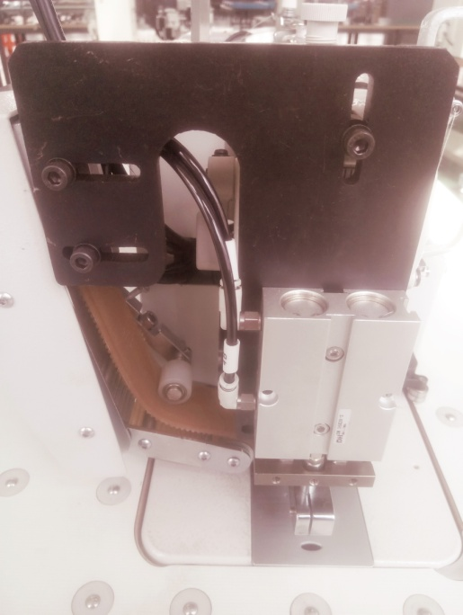

A
- Open the cover of the front start and emergency stop switch every month, check whether the screws of the cutter and side push mechanism are loose, tighten any, and clean up the excess chips.
(8) The default power supply voltage of the municipal power grid is 200-240VAC. If the actual voltage in any region is not in this range, it must be proposed when placing the order; otherwise, the machine damage and other losses caused by the different power supply voltage in different regions shall be borne by the demander itself.

III.Installation and Debugging
- Boot Check

After opening the package of the auto jig machine, first check the overall condition and see if any collision damage. If yes, please contact with processing logistics to deal with the damage. Then check if any screw loose or part falls off due to transportation vibration, or the controller, display boxes, connecting line between the presence of looseor fall off. If any, tighten and recover in situ installation.

- Electrical check and debug

- Air circuit check
Connect the air source to the control air pressure filter entry at the electric machine left rear side. At the moment of opening the air valve, below status will incur.
- The machine knife components raise;
- Internal and external presser foot lift;
- Side push wheel and corner detecting wheel return;
- Lifter pin retract to sewing table hole;
- Push out value retract.
If any malfunction, please check the air supply and air circuits.
- Air pressure adjustment
To adjust the filter pressure regulating valve, the pressure need to adjust to 0.45 MPa. Depending on material of jigs, the best pressure is to ensure jigs moving smoothly. Fluctuations of main gas pipe pressure would cause the system unstable.
Attention: The machine has been set up basically, so check first and adjust it if any malfunction.
- Power check
Plug the machine power into an electric socket with PE wire. Press the power switch "ON" button below the right side of the machine to switch ON. The display box and touch screen of the sewing machine show normal and no fault display. The touchscreen display is as follows:



Select ‘English’ as the language to enter into the home page.

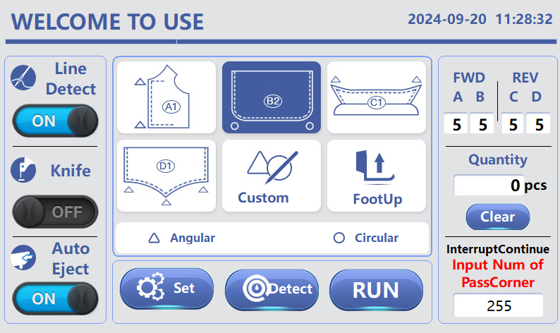

Click on the "Parameter Setting" button on the touch screen to enter the parameter settings page. Click the white bottom bars on the right side of "Straightspeed" and "Knife speed" respectively. As shown in the figure below, adjust the speed of the sewing machine and knife motor to the minimum. Press "return" button to return to the home page.

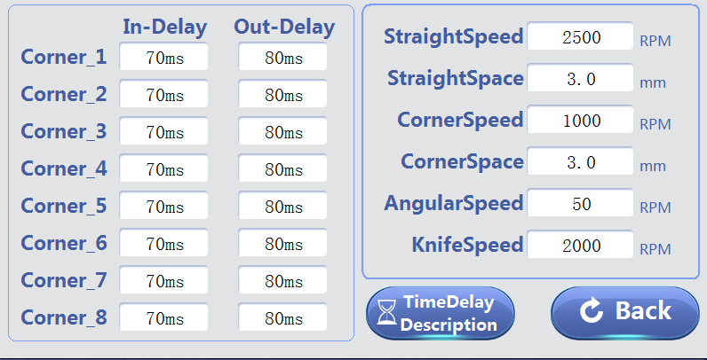

Select ‘Detect’ and the touchscreen display is as follows:

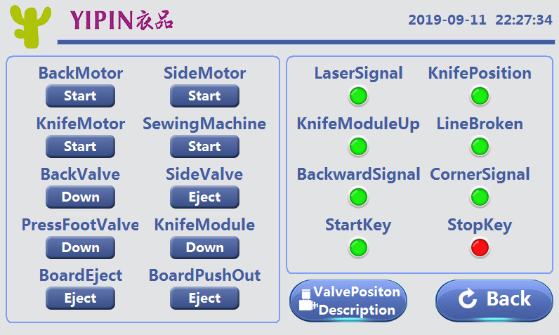

At this point, the left half is the actuator, you can click the button on the right respectively, and the corresponding mechanism will run or act. If not, check whether the lead is normal, whether there is stuck, etc. The right side is the signal detection, the sensor, induction switch, etc., change the position or state, the display will switch between red and green, if the switch is normal,
Without switching, check whether the lead is loose, etc. The inspection method of broken thread detection is to dial the thread picking spring with your hand and let it leave the copper sheet to see the change, as indicated by the arrow in the following figure:
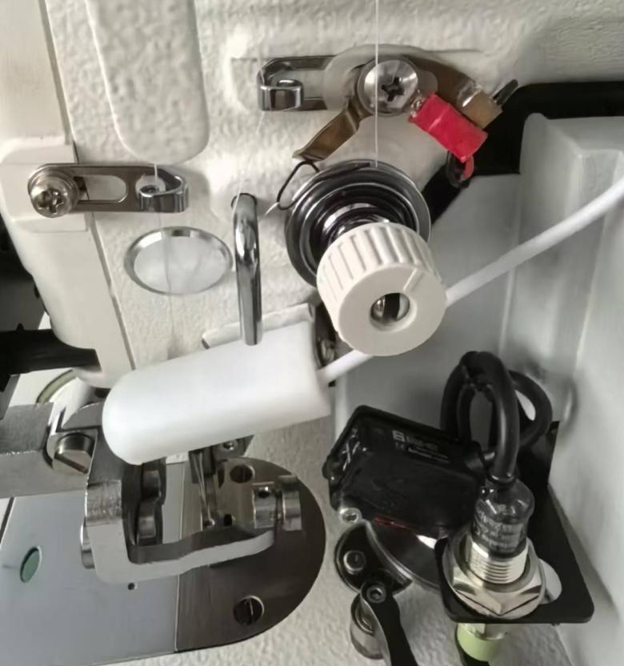

Note: to prevent accidental damage caused by multiple function running at the same time, please don't turn on multiple function at the same time.Only turn on a single function each time. After checking one function, first turn it off and then open another function.
After some functions are selected, there will be a prompt, if click "cutter motor", the following prompt page will appear:

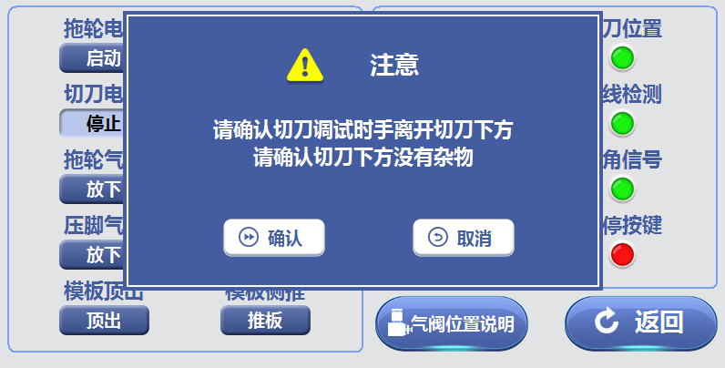

At this point, please press the prompts to check the relevant content, and then click "confirm".

Click on the "valve position description" button to enter the following page:

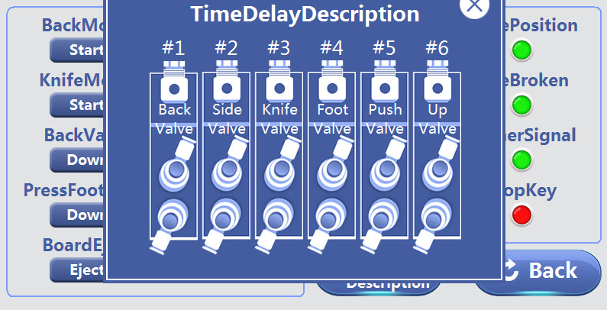

Indicated below is the position of the valve on the side of the control box under the sewing table.

- Checking and adjustment of the back puller
Put the jig under the needle plate. Then put down the back puller, and push with hands. It should be not tight or loose, and the whole process can drive the synchronous belt simultaneously. If it is tight or loose, loosen the screw shown as the following figure and move the back puller assembly to the appropriate position.

Adjust the screw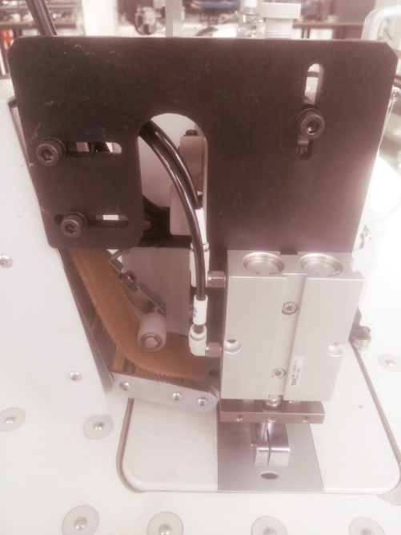

If the synchronous belt is not parallel to the template, loosen the screw that is shown below and swing the puller component to the left and right until parallel, then tighten the screw. Then check if the pressure of the tugboatpuller is suitable. If not, then adjust use the above method. At the same time, when the synchronous belt is under pressure, check whether the two sides of the guide slot are symmetric. If not, the puller mechanism can be moved and adjusted to the appropriate position.

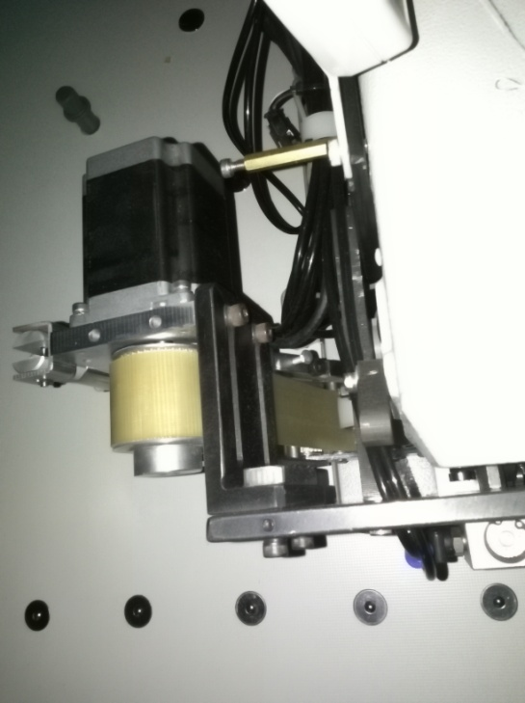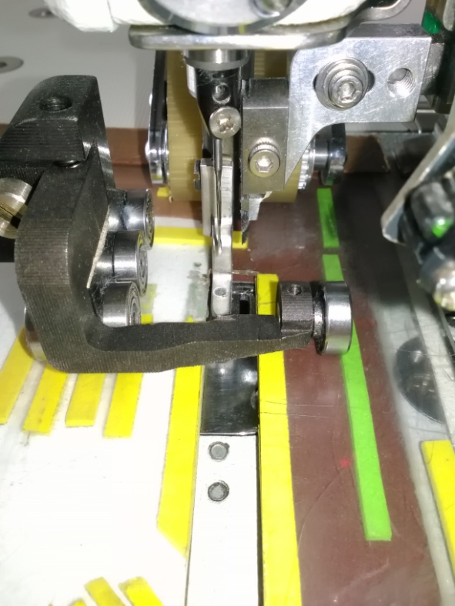

E. Side puller check and adjustment

Lift the back puller and extend the side puller, also using the hand push. The normal condition is that the whole process is neither tight nor loose, and the side push synchronization wheel can drive at the same time without slipping. If loose (not too much), stick medical tape onto the lower edge of the jig to widen the edge size, until meet the requirements. If too loose, check whether the jig size is in line with the requirements. Change the jig if it does not conform. During actual operation, if the back puller is lowered after the jig rotates only a small angle, then the reason may be that corner detect switch is too close and near threshold. In this case, lower the switch a bit, around 2-3mm. Or move to the left, and try again until normal.

F. Synchronous belt pinch roller adjustment

If during operation, a synchronous belt leaves and deviates the synchronous wheel, the pinch roller shown in the figure below can be adjusted. Move the pinch roller to the left if the synchronous belt move leftward shown as below condition. On the contrary, move to the right and no-load running for a period of time.
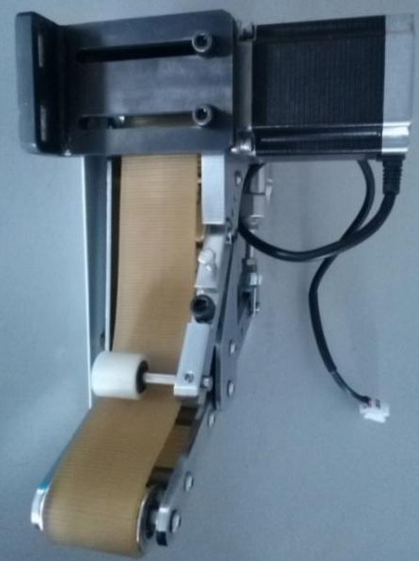 Pinch roller

G. Template pressure check

Note: In order to ensure the sewing stitch is consistent, it must ensure that the back puller puts the same pressure on jig in the whole process. Same for the side puller. Otherwise it will affect the stitch consistency. If the stitch is different, especially in the beginning and the corner of the position, the back puller is pressed on the edge of the jig, the pressure is not enough. So paste sponge rodsto the jig to add thickness, as shown in the following illustration.

Add sponge rods

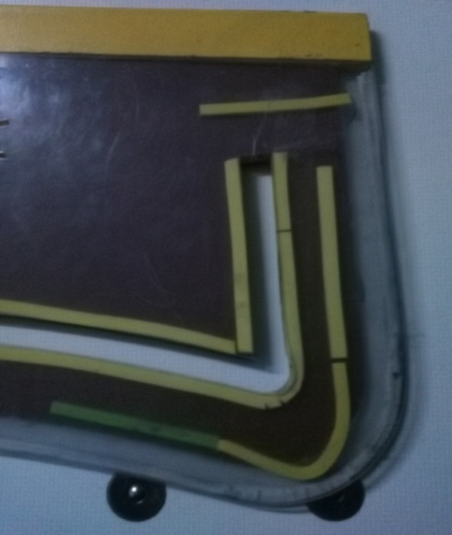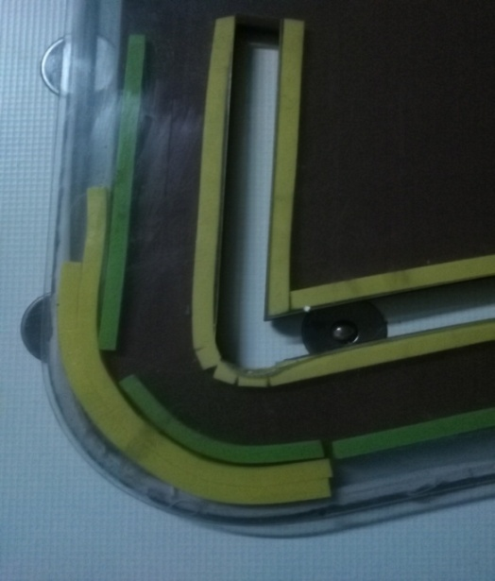

If the side thrust is inconsistent, the medical adhesive tape can be used to paste around the underside of the jig.

H. Corner detect switch check
Continuously pushing forward the jig to the rounded corner, corner detection wheel will automatically scroll left along the jig, and corner detect switch will shine.Corner detection wheel would go back when the jig spins through the corner and its back edge becomes perpendicular to sewing table. Check whether the corner detectswitch indicator light will be off. If yes, then it is normal. Shown as figure below.

Corner Detect Switch

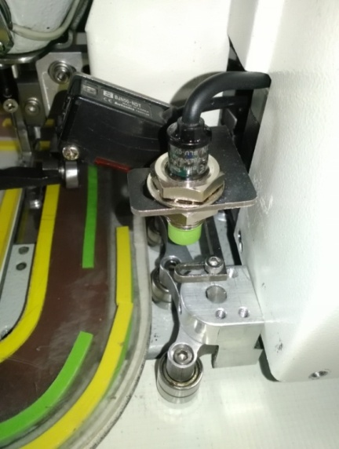

I. Determine the endpoint signal
Clip white paper in the jig. Push the jig from the beginning to the end of the last edge of the jig, wherethe last stitch locates.At this time, the photoelectric switch emits red light on the jig.It is where the reflective paper should stick. In order to avoid the jig offset and not detected, photosensitive paper is better with a long shape (width greater than 5mm). As shown below.
Photosensitive paper
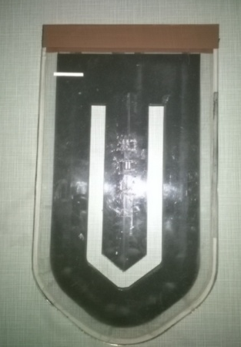

Sensitivity adjustment
Clip a piece of white paper or cloth within the jig and swing at the beginning of the jig, leaving it with a maximum range of movement. Push the jig until the end of last one side edge position. Notice that the red indicator lights on the photoelectric switch cannot be bright, the green indicator can be on or off, the red indicator light should turn on when the jig moves to the end edge of thereflective paper. During the process if the red light turns on, the sensitivity is too high. To adjust,use an appropriate small knob screw adjusting MIN – MAX knob, slightly rotate counterclockwise as shown in the graph until it meets the requirements. Do not apply much force, otherwise it will damage the adjusting knob.
Note: two knobs, which a small knob of D-L points set to L, cannot change position.

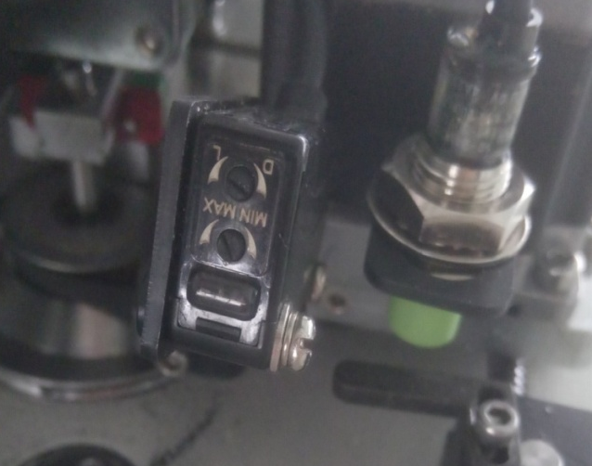

Sensitivity adjusting knob

J. the installation and inspection of cutting knives

Cut off the power supply and open the front cover with the start and emergency stop switch. Shut off the gas source to release the gas within the cylinder. Then the cutting knife components fall. Spin the eccentric gyration cutting knife motor with the hand to adjust the upper knife to the lowest position, where the upper knife and the edge of the bottom knife on the needle plate coincide. Check whether the two edge fit closely without adding pressure, as below graph.
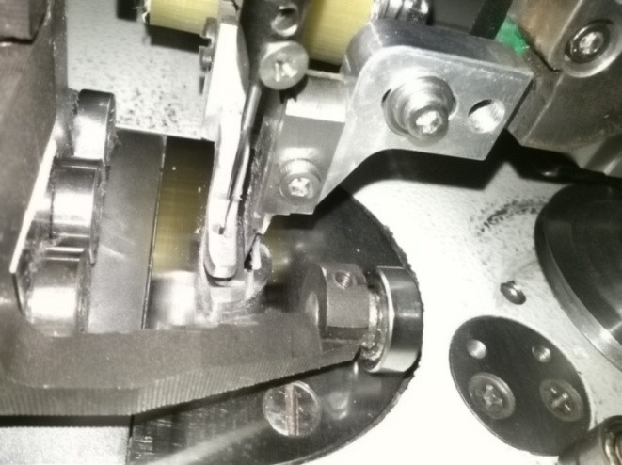
Bottom knife upper knife screw down gap adjustment

If the knife do not have a good grip, loosen the set screw, press softly from the right side of the knife to the left side and then tighten the screw. If there is a slight gap at the front side while the back side fits, adjust clearance adjustment screw until it fits. If there is a gap on the back side while the front side fits, adjust the adjustment screw on the rear panel. Slightly loosen the fastening screw at the side that need to adjust, as shown below of G1, and then tighten the screws T1, T2, as shown in the figure.

G1 G2 G3
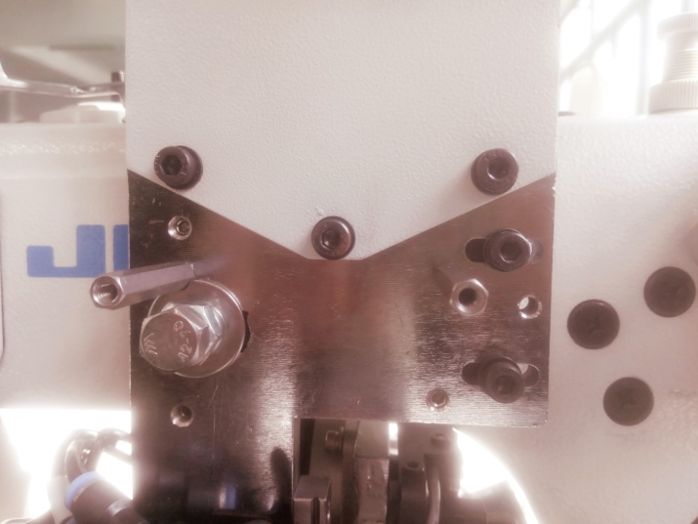
T1 T2 T3

After adjustment, tighten the tightening nut of the adjusting screw. Pull in thread with the hand, in between the upper and bottom knives. Spin the eccentric gyration cutting knife motor with the hand and make it move up and down on the knife.

Adjustment is done when the knife can simply cut off the thread with front, mid and end parts of the edge.
Check whether the frontside point of the knife has a gap of 0.2-0.5mm with the front end of the bottom knife hole. As shown below.

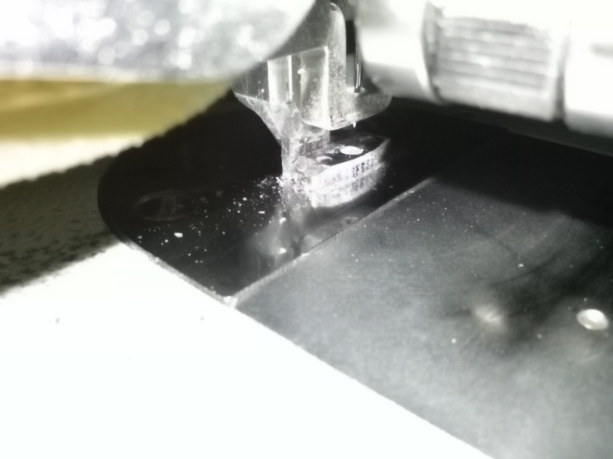
Upper knife Bottomknife 0.2-0.5mm （rear view）

If it is not, then need to adjust.
Method 1. Adjust J, as shown T2, T3 in the graph, and ensure the side push wheel and the sewing table parallel.
Method 2. Install the screw through two cutter guide rail shown as below, adjust the angle of cutter components until meet the criteria, and then tighten the two screws. As shown below.

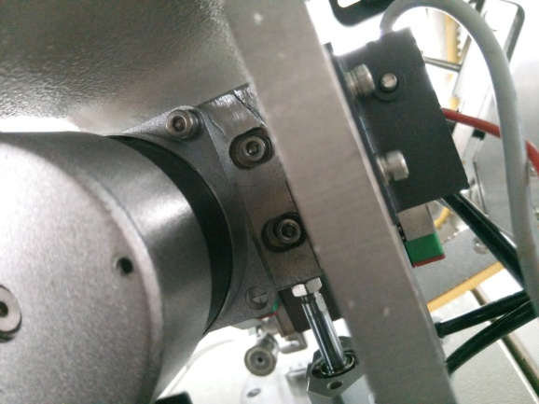

K. Adjust internal pressure foot

The height of the inner pressure foot should be adjusted according to the material thickness. When the internal pressure feet are lowered, keep a distance with the cloth.
L. Adjust out pressure foot
When the out pressure foot is down, there is a slight pressure on the jig. The good state is that moving the jig back and forth is easy, and the left and right bearings should have rolling. If too much pressure, it would affect the drag and bow thrust movement. At this point, adjust the small pressure regulating valve 4A shown as below, near the valve on the side of control box that is below sewing table. Reduce or increase the gas pressure until suitable.

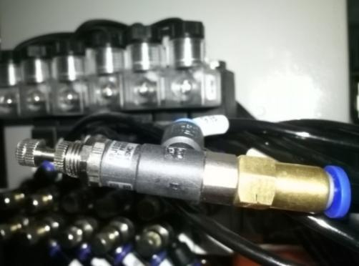
M. other cylinder pressure adjustment
As shown in the following diagram, from left to right is 1AB- 6AB.
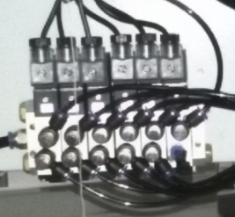

Speed control valve’s up is A, down is B:
1AB: up/down control of the back puller. 1A: clockwise turn is slow down the down speed of back puller, anticlockwise turn is speed up. 1B: clockwise turn is slow down the up speed, anticlockwise is speed up.
2AB: eject and back control of side puller and corner detect valve, this is parallel use for two valves. 2A: clockwise turn is slow down the eject speed, anticlockwise is speedup. 2B: clockwise is slow down the back speed, anticlockwise is speed up. The corner detect valve’s ejection is not only using the spring force, also use valve air pressure, can use the reducing valve 2A to reduce the pressure, clockwise is increase pressure, anticlockwise is reduce. Ensure the pressure is not too much, don’t cause a impact or pressure to template.

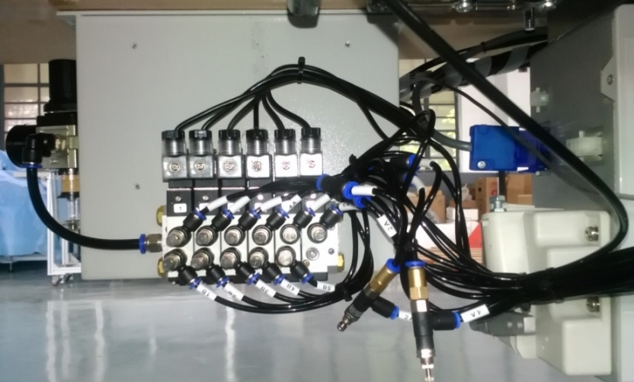
Miniature pressure relief valve

3AB: up/down control of knife module valve. 3A: clockwise is slow down the down speed, anticlockwise is speed up. 3B: clockwise is slow down the up speed, anticlockwise is speed up..
4AB: up/down control of inner/outside presser foot. 4A: clockwise is slow down the down speed, anticlockwise is speed up. 4B: clockwise is slow down the up speed, anticlockwise is speed up. Outside foot presser’s pressure is modify by reducing valve 4A, clockwise is increase pressure, anticlockwiseis reduce.
5AB: push out valve. 5A: clockwise is slow down the push out speed, anticlockwise is speed up. 5B: clockwise is slow down the pushrod back speed, anticlockwise is speed up.
6AB: template jack up valve. 6A: clockwise is slow down the speed of jacking up template, anticlockwise is speed up.

After push up, lift rod should eject 3.2- 3.8mm, less or more than the height, should push the sewing backward and adjust the screw shown as blow graph, move the air valve up or down, until meet the requirement then fasten the screw. Ensure the lift rod is in the middle of the hole, to avoid collision.
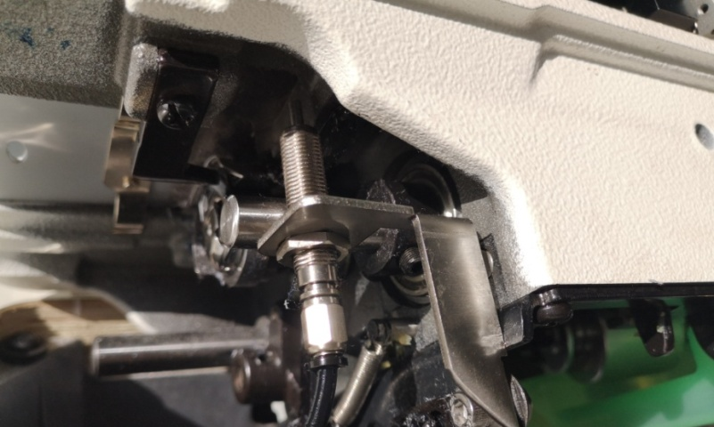

fasten screw

N：Sewing head setting:

(A)、The operating parameters of the sewing machine can be changed through the head operating panel. The internal parameters of the AUTO JIG machine have been properly modified according to the needs. In general, do not restore the factory parameters, otherwise it will change the set parameters and cause the normal operation. If factory parameters must be restored, please press the following reset: Under ordinary sewing state, long press "M" for 3 seconds to enter the "Function Setting" mode:

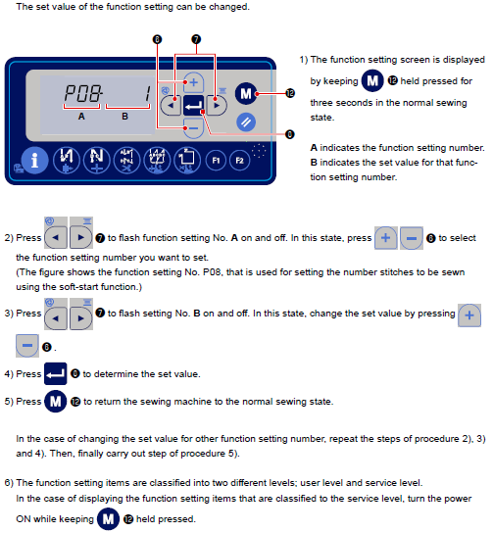

1、P01- Maximum sewing speed: the default value is 3000, changed to 4000
2、P04- Start reverse stitching speed: the default value is 1900, changed to 1300
3、 P05- End reverse stitching speed: the default value is 1900, changed to 1300
4、P18- start reverse seam solenoid valve ON timing correction: the default value is 123, changed to 0
5、P19- Solenoid valve OFF timing correction: the default value is 130, changed to 0
6、P25- end reverse seam solenoid valve ON timing correction: the default value is 123, changed to 0
7、P26- the solenoid valve to end the reverse seam OFF timing correction: the default value is 130, changed to 0

Adjust the upper stop needle position: The sewing machine automatically lifts the presser foot and observes whether the needle tip exceeds the lower plane of the presser foot. Make sure it is a little lower. If it exceeds too much, it needs to be set.

When the power is off, press the "M" key switch and switch ON the power (ON) at the same time to enter the "Service Level" mode.

Adjust to: P72- The adjustment mode of stopping Angle over the needle: the default value is " -0", rotate the nose handwheel slightly, observe the position of the needle tip to an appropriate position (data shows that around 16 is preferred), and then press "" on the nose panel. Power off and restart. Check whether the automatic thread cutting is normal at the end of each sewing. If the thread can't be cut well each time, repeat the setting and return the position of the needle to a point. Or the stop position is not accurate, it is necessary to fine-tune the cutting line structure and adjust the cutting time.

（B）、Panel Function Setting
1、choose free sewing mode,
2、front and rear reinforcement function setting: Set to pass：
3、wire cutting function setting: according to the need to set. Generally choose effective, that is, display scissors pattern.
4、Soft start function Settings: select effective.
5、The needle position is selected as the down needle position when the machine stops midway.
6、the selection of lifting foot: automatic lifting after cutting line.
7. The power switch shown in the following figure of the flat seam machine is always placed in the "ON":

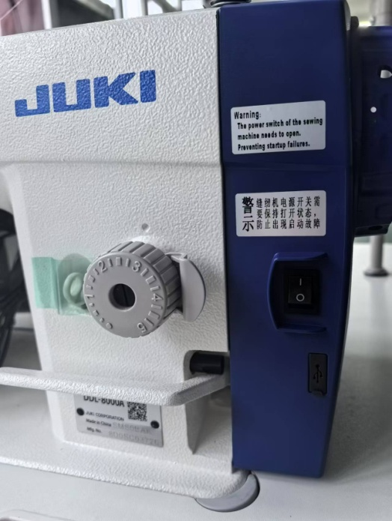

O: attention of making jig
Any type of jig with knife, must ensure this size blow, the distance between guideway and outer boundary is 41.5mm, width of guideway is 11.5mm, the thickness of jig is 1.5mm. By the way, start and stop point of guideway only consider the size of bottom knife, doesn't consider the size of cloth, it depends on the actual requirements.

Any type of jig without knife(diameter of guidepost is Φ3mm, must ensure these size blow, the distance between guideway and outer boundary is 50.5mm, the width of guideway is 3.2mm, thickness of jig is 1.5mm.
The necessary work before any jig using: enter the self detection page, put in the jig, let knife module down, turn the knife to bottom, push jig forward by hand. Check whether jig rub with knife, especially in the corner, ensure the backside knife doesn't rub with jig(better with distance 0.5mm), then let side puller eject, start the side motor, pull the jig to the end, better doesn't rub with jig. Otherwise, modify the top layer of jig. After that, enter parameter page, set the knife speed to minimum, test running with knife, prepare to press emergency stop button anytime, to avoid hurt people by knife broken.
When using jig without knife, suggest take down the upper knife and bottom knife, also set the knife function to OFF on the home page, otherwise it will cause the damage of knife and hurt people. Change the knife needle plate to circular hole needle plate, take down the inner and outside presser foot, change the 360d°presser foot or other suitable presser foot, modify the height to make sure jig can move smoothly and also be keep down.
IV. Operation

- Home page setup

Home page Settings: After entering the home page, select the appropriate pattern according to the shape of the template, and set the corresponding parameters in the "Parameter Settings" page, return to the home page, on the home page, select ON / OFF, ON, ON / OFF, ON has this function, OFF does not have this function. In addition, when the front and rear reinforcement joints are selected, the corresponding box of A, B, C and D of the screen can be filled with the corresponding number of needles. When the value is all "0", there is no reinforcement joint.

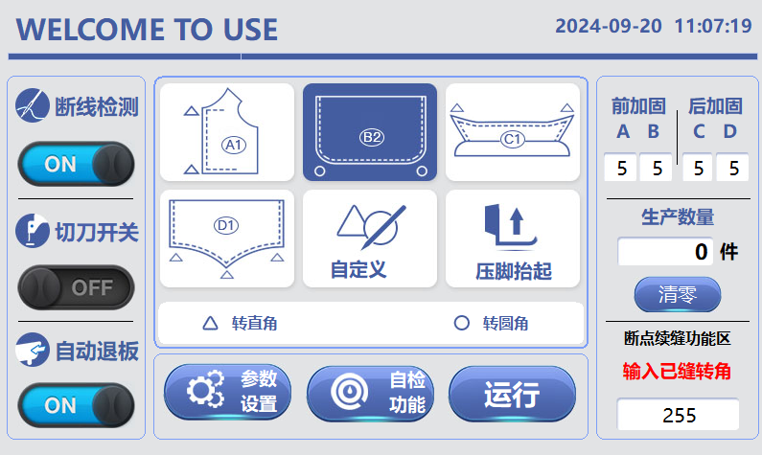

In addition, it must be noted to close the front and rear reinforcement sewing selection switch on the flat sewing machine panel, and the arrow below indicates the switch:
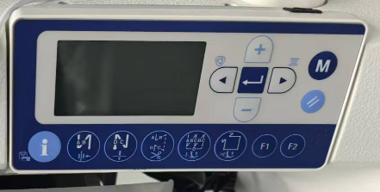

Push down the green button of the start switch, at the front side of the bottom of the sewing machine head. The auto jig machine will immediately begin to run. The red button is for emergency switch. After pushing down this button, the auto jig machine will stop running immediately.

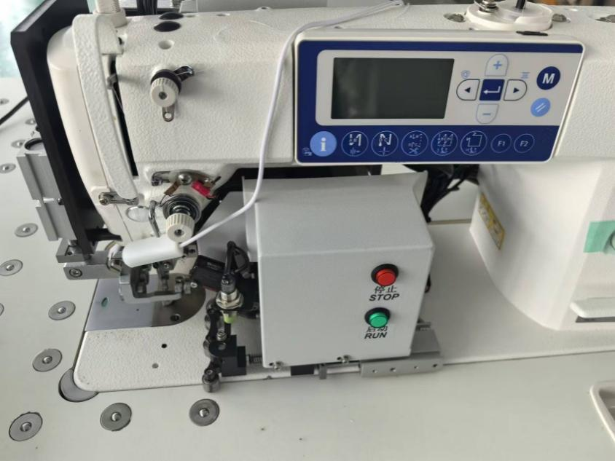

2．The home page is as follows.

Each time when press presser foot up button on the main page, the inner presser foot will automatically lift 60S then put it down. But whenever the sewing begins, the inner presser foot will be lowered automatically.
The "Run" switch on the home page clicks to clear the line break and emergency stop alarm page, and can be run directly.
The five patterns displayed in the upper middle are major items of template shape. After each pattern is clicked, the lower layer has further refined patterns, from left to right as shown below:
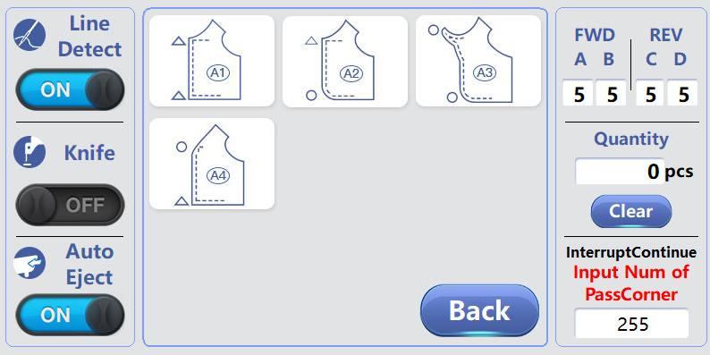

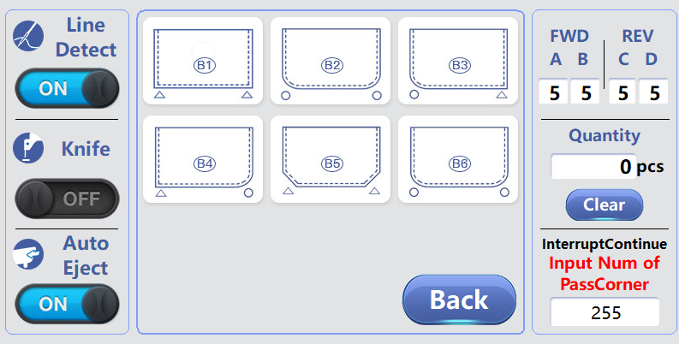

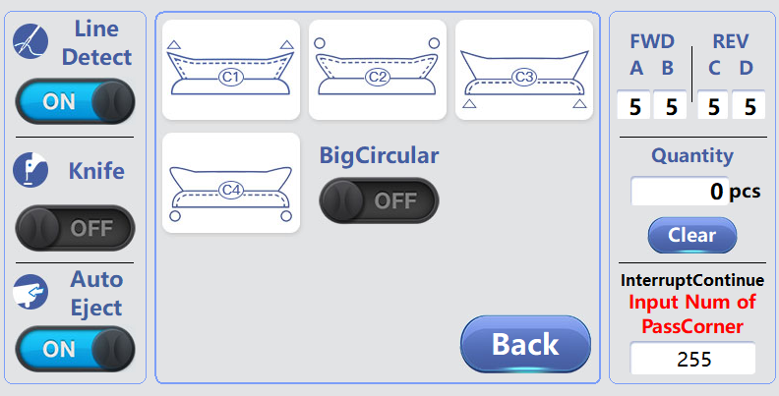

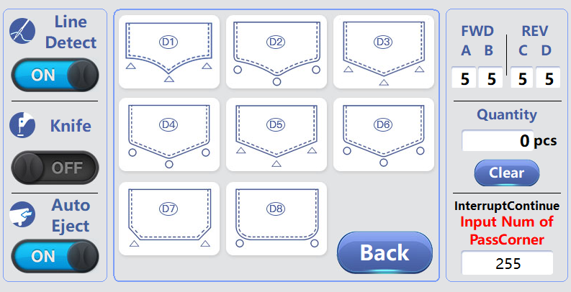

There is a "Sewing Reserved" key in the upper left corner, which deals with a special process: Sometimes leave a period of no sewing but cut in the start and end, (otherwise knife will stab cloth to cut properly, after a long time can cause cutter body position change and abnormal trimming). therefore, when " Sewing Reserved " is selected, according to the main page's selected model will cut at first, sewing when reach the first sensitive point set, began to cut and sewing at the same time, until the second photosensitive point, the machine reinforce sewing then stop, but other actions still running, continue to cut the remaining edge of the cloth and after detect the third sensitive point, the machine whole stop.

On the collar and triad collar seam page, in the figure below "bigCircular", refers to the individual collar Angle is big arc shape, at this point, need to choose the function, click on the box, make it displayed as "ON", press the "return" box return to the main page, and in the template in and out of the corner reflective paper, through photoelectric sensor to detect Angle, can sew big Angle of the template.

This feature works with various templates. Specific operation: after selecting the template pattern on the main page, press the custom key to enter the custom page, click " Sewing Reserved " to turn it into inverse color display, and return to the main page, press the normal operation, but the template must also be pasted three sensitive point in the appropriate position according to the requirements.

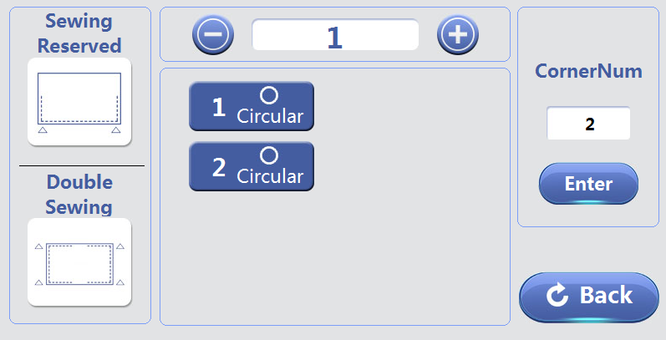

The "Double Sewing" key in the upper left corner is a special process: sometimes the front and back requirements to leave a section without sewing. Therefore, when the "before and after seam reserved" key selection for "ON", the main page selection mode cut a first, to set the photosensitive point, start cutting at the same time, until the end of the second point, the machine stop after the reinforcement seam, but other action still continue to run, cutting knife continue to cut the remaining cloth, until detected the third last point, the machine all stop. This function is applicable to the various templates. Specific operation: after selecting the template pattern in the main page, press the custom key, enter the custom page, select the "front and rear seam reserved" key as "ON", return to the main page, press the normal operation, but the template must be posted in the appropriate position in advance.
Lower left corner of the "double sewing", refers to a template can sew two products of the same shape, click into dark, press the "return" back to the main page, can sew double spell template, namely a template can sew two of the same products, the end of the first product automatically complete cutting and empty go to the beginning of the next product automatically continue to sew until complete the whole process.
3. Setup of corner time delay
Before running, click Parameter Setup button to enter the parameter setting page and set the following parameters.

The speed of the straight stitch is the operating speed of the sewing machine, which can reach up to 4000RPM. But it needs to be set properly according to the different jig and ensure the steadiness of the jigs. The cutting speed is better to be 300 to 500RPM lower than the sewing machine's speed. It depends on the quality of the cutting cloth.

To set up the left side of the corner time delay parameter, every corner has a Corner In, Corner Out delay set. For each jig corner, respectively set up the delay execution speed of the circular or angular seam after the corner angle signal is detected. The first corner always starts from the right side of the jig, as the jig always runs counterclockwise. Click the Delay Settings box, as shown below.

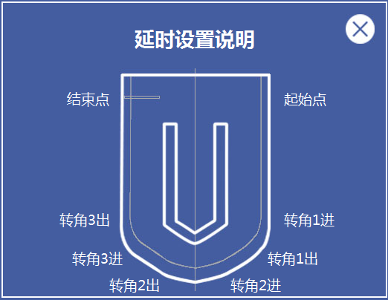

Extra corner parameters do not have to be set up and will not affect the execution of the program.
The parameters of corner time delay directly affect the quality of sewing stitches. Following setup method is suggested.
Clipped a piece of thick paper in the jig and use the default delay setup to run the machine. See if the stitches are even. If before the rounded corners appear below condition in the figure A, then the delay time for Corner In is too short because the machine performs corner speed in advance. So increase the delay time of Corner In depending on the size of the jump stitch, until it is ideal. Conversely, the opposite is done.
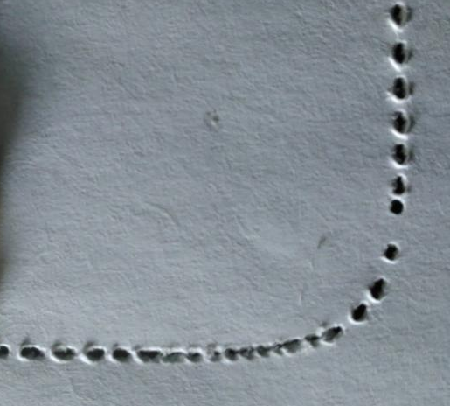
B：corner out delay is short A：corner in delay is short

If the above condition B appears after the round corner, then it means Corner Out delay time is too short because the machine still performs the straight speed at a round section. So increase the delay time of Corner Out depending on the size of the jump stitch, until it is ideal. Conversely, the opposite is done.
If it's hard to achieve the desired stitch, move round corner detection approach switch to the right or move the metal detection strip to the left, in order to let the proximity switch detect the enter and delay of the jig to the corner in advance. This helps lengthen the delay time and makes adjustment easier.
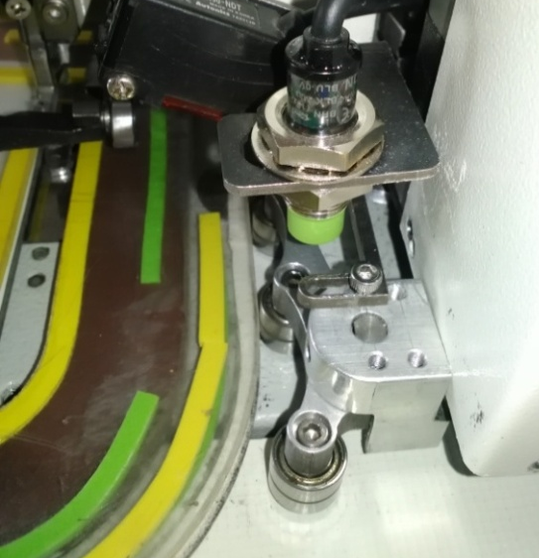
Metal detection strip corner detect switch

Below are two possible situations appear if adjusting corner in and out time delay still cannot solve.

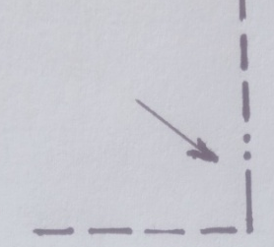
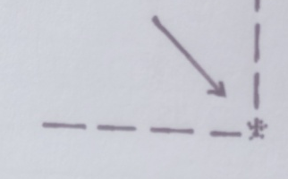 angular close stitch
figure 3.1 figure 3.2
If the situation shown in figure 3.1 appears, there is due to no turn at the corner. Move the metal detection strip of the corner detect switch to the left, until the operation is normal.

If the situation shown in figure 3.2 appears, then it is caused by early turn to the corner. Move the metal detection strip of the corner detect switch to the right, until the operation is normal.

Each pattern corresponds to a jig. After debugging proper time delay parameters and the parameters such as the speed, the setup is automatically saved. Next time when using this jig, just select the same pattern, all parameters such as delay or the speed is not necessary to reset and will automatically be obtained. In order to prevent the error program due to replacement of jig, it is recommended to number each jig that with different parameters and shapes.

Click the custom buttonto enter a Custom Settings page. It provides users with 10 kinds of independent user set corner numbers of Angular or Circular and sequences. After setup completed, press the Confirm button. Then the jig machine can operate as setup. The delay setting method of each Corner In and Corner Out is the same. Following graph for reference.

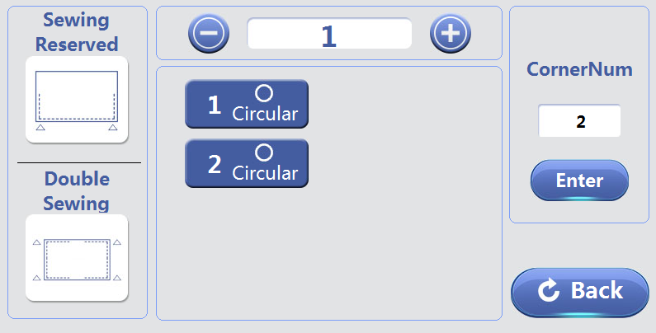

You can customize the shape of less than 10 templates, press the upper row of "+", add or adjust the set number of template set shape, "-" the opposite. Click on the right side of the "corner number" under the white box, enter the number of the corner, the left box will appear the same number of small box, click on each small box, there will be "round" "right" swap, according to the actual template each corner shape set, press the confirmation key is saved, press the "return" key back to the home page. The le delay can memory the 10 template parameters.

4. Use of line broken detection function
The machine has the function of breaking line detection. After several needles stitches, the machine will start testing, and any unthreaded or broken line will stop the machine and trigger the alarm. The screen display is as follows.
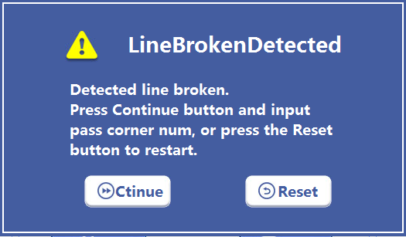
Select the options you want to use. After selecting the continuous stitches and input the number of the corners pass already, press the start button to continue to sew the unfinished part.
If you press the Stop button, the following display will appear. Follow the instruction as the line is broken.
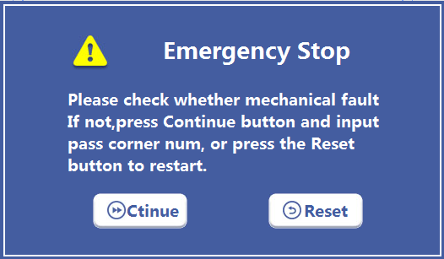

For convenience to debug, the thread test on the touch screen can be selected as "OFF". Then the machine can operate normally without threading.
5. Key points of stitches improvement
After the straight seam speed is more than a certain speed, the stitching maybe creased, and the suggestion is that the stitch size can be small and the crease will improve a lot.
The corners of the template bend are not flat, can raise the internal pressure a little, and modify the corner in time delay to be appropriate, the stitch will have a great improvement.
6. Pushing mechanism adjustment
When the machine sewing various size of different jigs, some jigs may not be easily push out. In that case, adjust the rear panel mounting holes of 10 mm on the left and right side. The premise is not to influence the normal operation of the jig.Also the L shape pedestal can move left and right to adjust distance.
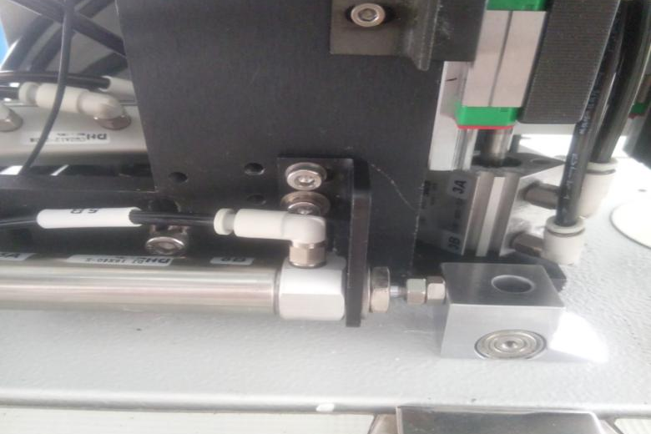
adjustment screw

V. Fault type, code and debug
The machine is equipped with automatic alarm and a simple prompt processing method would be shown on the screen.
After the alarm, it is necessary to restart the machine to recover. If the alarm still exists after following the preliminary troubleshooting instruction, please contact the local dealer or manufacturer.
ErrorType | ErrorName | Comment
E01 | OverVoltage | Over voltage Error, please check the  power supply and reset.
E02 | LackVoltage | Low voltage Error, please check the  power supply and reset.
E03 | Sewing Machine do not run | Sewing machine error, please check the  connector and reset.
E04 | No Index signal | Please check the encoder and reset.
E05 | No AB signal | Please check the encoder and reset.
E06 | Side Motor over current | Please check whether the side  motor is blocked or overcurrent.
E07 | Side Motor blocked | Please check the side motor and reset.
E08 | Back Motor over current | Please check whether the back motor is blocked or overcurrent.
E09 | Back Motor blocked | Please check the back motor and reset.
E10 | EEPROM error | EEPROM error, please contact the dealer.
E11 | Knife Motor over current | Please check whether the knife motor is blocked or overcurrent.
E12 | Knife Motor blocked | Please check whether the knife motor is blocked or overcurrent.
E13 | Module position error | Please check whether the Knife Module and FootPressor are up , and shut down the power to restart.
E14 | Knife Module position error | Please check whether the Knife Module is down, and shut down the power to restart.
E15 | Knife position error | Please check whether the Knife Sensor is normal, and shut down the power to restart.
E16 | Lack of AirPressure | Please check whether the AirPressure is 0.45MPa, and shut down the power to restart.
E17 | StopKey | Please check whether the stop key is always close, and shut down the power to restart.
E18 | StartKey | Please check whether the start key is always close, and shut down the power to restart.
E19 | Reinforce pin num error | The reinforce pin number is different between Touch screen and sewing machine.

Parts Manual

No. | PartNo. |  | PartName |  |  | No. | PartNo. |  | PartName
1 | C01 |  | Step Motor |  |  | 30 | C30 |  | Cylinder connecting rod
2 | C02 |  | M4×14 socket head cap screw |  |  | 31 | C31 |  | M3×10soket head cap screw
3 | C03 |  | Φ4Spring gasket |  |  | 32 | C32 |  | Φ3Spring gasket
4 | C04 |  | Φ4Flat gasket |  |  | 33 | C33 |  | Φ3Flat gasket
5 | C05 |  | Synchronizing wheel |  |  | 34 | C34 |  | 12mmlead rail
6 | C06 |  | Synchronous belt |  |  | 35 | C35 |  | M3×14soket head cap screw
7 | C07 |  | Spring Collar |  |  | 36 | C36 |  | Side push assembly plate
8 | C08 |  | Bearing |  |  | 37 | C37 |  | Φ3Spring gasket
9 | C09 |  | Synchronizing wheel |  |  | 38 | C38 |  | M3×10soket head cap screw
10 | C10 |  | Bearing |  |  | 39 | C39 |  | M12nut
11 | C11 |  | Shaft |  |  | 40 | C40 |  | Φ12 Flat gasket
12 | C12 |  | M4 nut |  |  | 41 | C41 |  | Proximity switch
13 | C13 |  | Φ4Spring gasket |  |  | 42 | C42 |  | Switch mounting plate
14 | C14 |  | Φ4Flat gasket |  |  | 43 | C43 |  | Photoelectric switch
15 | C15 |  | Φ4Flat gasket |  |  | 44 | C44 |  | M3×14Triple combination screw
16 | C16 |  | Bearing |  |  | 45 | C45 |  | M3×5 socket head cap screw
17 | C17 |  | Pressing wheel shaft |  |  | 46 | C46 |  | Φ3Spring gasket
18 | C18 |  | M4×10 socket head cap screw |  |  | 47 | C47 |  | Φ3Flat gasket
19 | C19 |  | Φ4Spring gasket |  |  | 48 | C48 |  | M3×8 socket head cap screw
20 | C20 |  | Φ4Flat gasket |  |  | 49 | C49 |  | Φ3Flat gasket
21 | C21 |  | Side push cylinder mounting seat |  |  | 50 | C50 |  | Corner inducer
22 | C22 |  | M5Nut |  |  | 51 | C51 |  | M4×5set screw
23 | C23 |  | Cylinder |  |  | 52 | C52 |  | Corner test assembly
24 | C24 |  | Gas connector |  |  | 53 | C53 |  | M3×6 socket head cap screw
25 | C25 |  | Φ4Spring gasket |  |  | 54 | C54 |  | Rotation testing wheel mounting plate
26 | C26 |  | M4×16soket head cap screw |  |  | 55 | C55 |  | Bearing
27 | C27 |  | M3Nut |  |  | 56 | C56 |  | Rotation test component wheel shaft
28 | C28 |  | Φ3Spring gasket |  |  | 57 | C57 |  | Bearing
29 | C29 |  | Φ3Flat gasket |  |  | 58 | C58 |  | Bearing shaft
No. |  | PartNo. |  | PartName |  | No. |  | PartNo. |  | PartName
59 |  | C59 |  | M5Nut |  | 71 |  | C71 |  | M3×4 set screw
60 |  | C60 |  | Spring |  | 72 |  | C72 |  | Cylinder
61 |  | C61 |  | Φ5Flat gasket |  | 73 |  | C73 |  | Gas connector
62 |  | C62 |  | Linear bearing |  | 74 |  | C74 |  | Φ3Spring gasket
63 |  | C63 |  | Bearing mounting seat |  | 75 |  | C75 |  | M3×16soket head cap screw
64 |  | C64 |  | Φ3Spring gasket |  | 76 |  | C76 |  | M16Fastening ring
65 |  | C65 |  | Φ3Flat gasket |  | 77 |  | C77 |  | Green button switch
66 |  | C66 |  | M3×16soket head cap screw |  | 78 |  | C78 |  | Red button switch
67 |  | C67 |  | Template limit sliding rod |  | 79 |  | C79 |  | M3×6soket head cap screw
68 |  | C68 |  | Cylinder slide bar gauge plate |  | 80 |  | C80 |  | Φ3Flat gasket
69 |  | C69 |  | M4×5soket head cap screw |  | 81 |  | JC81 |  | Shield
70 |  | C70 |  | M3×4set screw |  | 82

No. | PartNo. | PartName |  | No. | PartNo. | PartName
1 | D01 | Cylinder |  | 26 | D26 | M4×14socket head cap screw
2 | D02 | Gas connector |  | 27 | D27 | Φ4Spring gasket
3 | D03 | Φ8Shim |  | 28 | D28 | Φ4Flat gasket
4 | D04 | Side push cylinder mounting bracket |  | 29 | D29 | DC electric machinery
5 | D05 | M8nut |  | 30 | JD30 | Cutter motor mounting plate
6 | D06 | M5nut |  | 31 | D31 | 9mmlead rail
7 | D07 | Lateral thrust block |  | 32 | D32 | M3×12soket head cap screw
8 | D08 | Bearing |  | 33 | D33 | M4×12socket head cap screw
9 | D09 | Shaft |  | 34 | D34 | Φ4Spring gasket
10 | D10 | Bearing |  | 35 | D35 | M5nut
11 | D11 | M4×5Set screw |  | 36 | D36 | Cylinder
12 | D12 | M4×10 socket head cap screw |  | 37 | D37 | Gas connector
13 | D13 | Φ4 Spring gasket |  | 38 | D38 | Φ4 Flat gasket
14 | D14 | Φ4 Flat gasket |  | 39 | D39 | Φ4Spring gasket
15 | D15 | M4×10soket head cap screw |  | 40 | D40 | M4×10socket head cap screw
16 | D16 | Φ4Spring gasket |  | 41 | D41 | M3×10soket head cap screw
17 | D17 | Φ4Flat gasket |  | 42 | D42 | M4×4 Set screw
18 | D18 | Proximity switch mounting plate |  | 43 | D43 | Eccentric gear
19 | D19 | Proximity switch |  | 44 | D44 | M3×8 socket head cap screw
20 | D20 | M3×8soket head cap screw |  | 45 | D45 | Proximity switch
21 | JD21 | Side push cutter mounting plate |  | 46 | JD46 | Proximity switch mounting plate
22 | D22 | M5×20soket head cap screw |  | 47 | D47 | M4×8 socket head cap screw
23 | D23 | Φ5Spring gasket |  | 48 | D48 | Φ4Spring gasket
24 | D24 | Φ5Flat gasket |  | 49 | D49 | Φ4 Flat gasket
25 | D25 | Adjusting plate |  | 50 | D50 | M4×20 socket head cap screw
No. | PartNo. | PartName |  | No. | PartNo. | PartName
51 | D51 | Φ4Spring gasket |  | 66 | D66 | M5×4set screw
52 | D52 | Φ4Flat gasket |  | 67 | D67 | Top blade
53 | D53 | Cutter guide rail mounting plate |  | 68 | D68 | Blade pressing plate
54 | JD54 | Slideway cushion high board |  | 69 | D69 | Φ3Flat gasket
55 | D55 | 9mmSlideway slider |  | 70 | D70 | M3×12socket head cap screw
56 | D56 | M3×10socket head cap screw |  | 71 | D71 | Φ4Flat gasket
57 | D57 | M3×6socket head cap screw |  | 72 | D72 | Φ4Spring gasket
58 | D58 | Φ3Spring gasket |  | 73 | D73 | M4×12socket head cap screw
59 | D59 | Φ3Flat gasket |  | 74 | JD73 | Rear shield
60 | D60 | Bearing |  | 75 | D74 | Six angle supporting column
61 | D61 | Connecting rod |  | 76 | D75 | M4×6Large cross recessed pan head screws
62 | D62 | Couplet shaft |  | 77 | D76 | Φ6Rand
63 | JD63 | Blade mounting plate |  | 78
64 | D64 | M3×12socket head cap screw |  | 79
65 | D65 | Cutter seat |  | 80

No. | PartNo. | PartName |  | No. | PartNo. | PartName
1 | E01 | M4×16soket head cap screw |  | 29 | E29 | Tension Shaft
2 | E02 | Φ4Spring gasket |  | 30 | E30 | Connection bar
3 | E03 | Φ4 Flat gasket |  | 31 | E31 | Grommet
4 | E04 | Stepper motor |  | 32 | E32 | Shaft
5 | E05 | Stepper motor |  | 33 | E33 | Bearing
6 | E06 | Motor synchronizing wheel |  | 34 | E34 | Synchronizing wheel
7 | E07 | M4×5set screw |  | 35 | E35 | Connection bar
8 | E08 | Synchronous belt |  | 36 | E36 | Shaft
9 | E09 | M4×16Oblate hex head socket screws |  | 37 | E37 | Shaft
10 | E10 | Supporting shaft |  | 38 | E38 | Bearing
11 | E11 | Clout |  | 39 | E39 | Synchronizing wheel
12 | E12 | Connection strap |  | 40 | E40 | M5×25socket head cap screw
13 | E13 | M4×7.5Hexagonal prism |  | 41 | E41 | Φ5Spring gasket
14 | E14 | Shield |  | 42 | E42 | Φ5 Flat gasket
15 | E15 | M4×6 Oblate hex head socket screws |  | 43 | JE43 | End face mounting plate
16 | E16 | Rotating support plate |  | 44 | E44 | Gas connector
17 | E17 | M4×12socket head cap screw |  | 45 | E45 | M4×25soket head cap screw
18 | E18 | Φ4 Spring gasket |  | 46 | E46 | Φ4Spring gasket
19 | E19 | Φ4 Flat gasket |  | 47 | E47 | Cylinder
20 | E20 | Rand |  | 48 | E48 | M4×5 set screw
21 | E21 | Tension plate |  | 49 | E49 | M5×10soket head cap screw
22 | E22 | Pivot pin |  | 50 | E50 | Shaft
23 | E23 | M4×30External hex head screws |  | 51 | E51 | Out presser foot bearer plate
24 | E24 | M5×20socket head cap screw |  | 52 | E52 | Bearing
25 | E25 | M4×5 Set screw |  | 53 | E53 | Shaft
26 | E26 | Rand |  | 54 | E54 | M3×4 set screw
27 | E27 | Bearing |  | 55 | E55 | M5×14socket head cap screw
28 | E28 | Nylon roller |  | 56 | E56 | M6×6 Set screw
No. | PartNo. | PartName |  | No. | PartNo. | PartName
57 | E57 | Spring |  | 69 | E69 | M5Nut
58 | E58 | Inner presser foot bearing support plate |  | 70 | E70 | Rod end joint
59 | E59 | M3×4Set screw |  | 71 | E71 | Rod end joint pin buckle
60 | E60 | Shaft |  | 72 | E72 | Gas connector
61 | E61 | Shaft |  | 73 | E73 | Rand
62 | E62 | Bearing |  | 74 | E74 | Cylinder fixed seat
63 | JE63 | Connecting plate |  | 75 | E75 | Shaft pin
64 | E64 | Φ5 Flat gasket |  | 76 | E76 | Φ4 Flat gasket
65 | E65 | Φ5 Spring gasket |  | 77 | E77 | M4×10Deep head screw
66 | E66 | M5×20socket head cap screw |  | 78
67 | E67 | M5×6socket head cap screw |  | 79
68 | E68 | Cylinder |  | 80

No. | PartNo. | PartName |  | No. | PartNo. | PartName
1 | G1 | M10Nut |  | 1 | Z1 | Needle plate
2 | G2 | Φ10Flat gasket |  | 2 | Z2 | Fixed cutter
3 | JG3 | Mounting plate |  | 3
4 | G4 | Φ10Flat gasket |  | 4
5 | G5 | M10Nut |  | 5
6 | JG6 | Needle cylinder |  | 6
7 | JG7 | Gas connector |  | 7
8 |  |  |  | 8
9 |  |  |  | 9
10
11
12
13
14
15
16
17
18
19
20
21
22
23
24
25
26
27
28
29
30
31
32
33
34
35
36
37
38

No. | PartNo. | PartName |  | No. | PartNo. | PartName
1 | H01 | M4×6Cup head cruciform slot screw |  | 31
2 | H02 | Tank cover |  | 32
3 | H03 | M4×6three combination cross grooves |  | 33
4 | H04 | Control circuit board component |  | 34
5 | H05 | Box |  | 35
6 | H06 | Press plate |  | 36
7 | H07 | M4×12Cross recessed pan head screws; |  | 37
8 | H08 | Switching power supply module |  | 38
9 | H09 | Φ4Flat gasket |  | 39
10 | H10 | Φ4 Spring gasket |  | 40
11 | H11 | M4×6soket head cap screw |  | 41
12 | H12 | Decompression filtration valve assembly |  | 42
13 | H13 | Gas switch |  | 43
14 | H14 | Gas bending joint |  | 44
15 | H15 | Φ4Flat gasket |  | 45
16 | H16 | M4×10 socket head cap screw |  | 46
17 | H17 | Gas pressure hose |  | 47
18 | H18 | Gas connector |  | 48
19 | H19 | Silencer |  | 49
20 | H20 | Gas path plugging |  | 50
21 | H21 | Solenoid valve connecting plate |  | 51
22 | H22 | Φ4Flat gasket |  | 52
23 | H23 | Φ4Spring gasket |  | 53
24 | H24 | M4×25 socket head cap screw |  | 54
25 | H25 | Solenoid valve |  | 55
26 | H26 | Plug-in unit |  | 56
27 | H27 | Speed regulating joint |  | 57
28 | H28 | Miniature pressure relief valve |  | 58
29 | H29 | Φ4 Flat gasket |  | 59
30 | H30 | M3×30soket head cap screw |  | 60

No. | PartNo. | PartName |  | No. | PartNo. | PartName
1 | P01 | Protective box
2 | JP02 | Touch-screen component mounting plate
3 | P03 | M4×8socket head cap screw
4 | P04 | Fixed pressure plate
5 | P05 | M4×6socket head cap screw
6 | P06 | Touch screen
7 | P07 | 24VDCPower cord
8 | P08 | Communication line
9
10
11
12
13
14
15
16
17
18
19
20
21
22
23
24
25
26
27
28
29
30
31
32
33
34
35

