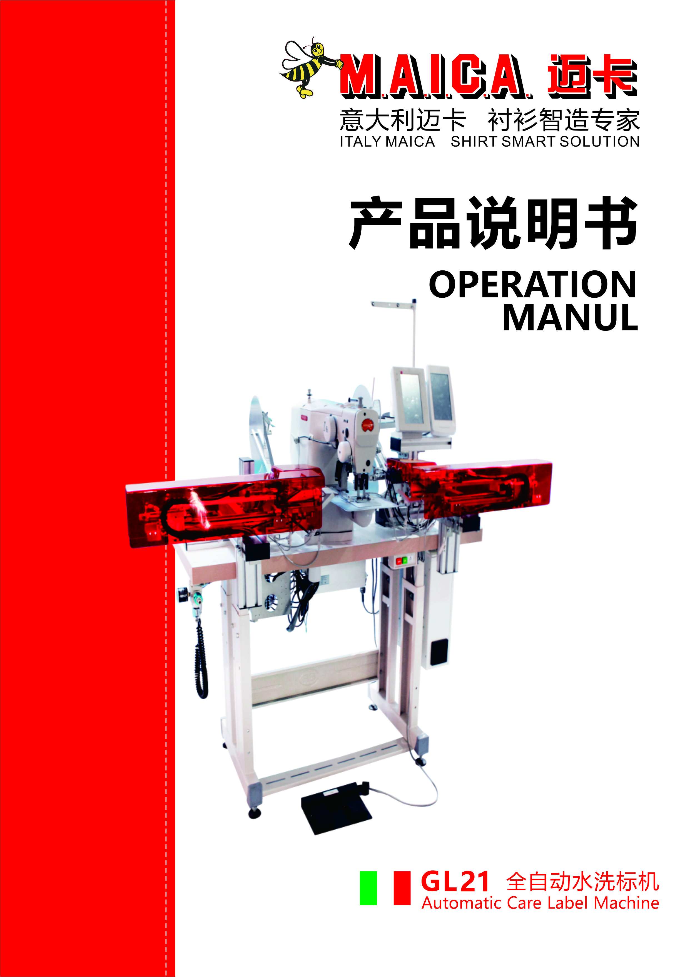

Safety Precautions
- Sign and Meanings of safe operation

The safety signs used in this instruction manual and the product are designed to allow you to use the product correctly and safely to prevent injury to you and others. The pattern and meaning of the logo are as follows:
 | If you ignore this mark and perform the wrong operation, it will result in serious injury or death.
 | If you ignore this mark and perform the wrong operation, it may result in personal injury and equipment damage.
 | This symbol indicates "should be noted". The pattern in the triangle indicates what must be noted. (For example, the pattern on the left indicates "Beware of injury")
 | This symbol means "prohibited"
 | This symbol indicates "must". The pattern in the circle indicates what must be done. (For example, the pattern on the left indicates "must be grounded")

2、Safety Precautions

 | When opening the electric control box, first turn off the power switch and unplug the power plug from the outlet, wait at least 5 minutes, then open the control box cover. Touching an area with a high voltage can cause personal injury.
Use environment
 | Avoid using the sewing machine near strong electrical interference sources such as high frequency welders.  Strong electrical interference sources may affect the normal operation of the sewing machine.。
The fluctuation of the power supply voltage should be used within ±10% of the rated voltage.
Large fluctuations in voltage can affect the normal operation of the sewing machine and require a voltage regulator.
The ambient temperature should be used in the range of 0 °C ~ 45 °C.
Low temperatures or high temperatures can affect the normal operation of the sewing machine.
 | The relative humidity should be in the range of 35% to 85%, and the device should not be used in the environment where condensation does not form. Dry, wet or dew condensation can affect the proper operation of the sewing machine.
 | The air supply to the compressed air should be greater than the total air consumption required by the sewing machine. Insufficient air supply to the compressed air can cause the sewing machine to malfunction.
 | In the event of a lightning storm, turn off the power switch and unplug the power cord from the outlet. Lightning can affect the correct operation of the sewing machine.
Installation
 | Please have a trained technician install the machine.
Do not connect the power supply and air pressure until the installation is complete.
If the start switch is pressed by mistake, the machine will cause injury.
 | When disassembling or moving the machine, use both hands. Do not press the machine hard. If the machine is out of balance, falling over to the ground can cause injury or damage.
 | Must be grounded. The grounding wire is not secure, which is the cause of electric shock or malfunction.
 | All cables should be secured at least 25 mm from the moving parts. Also, do not over-bend or over-tighten with staples. Risk of fire or electric shock

Sewing
 | This sewing machine is limited to those who have been trained in safe operation.
 | During the sewing process, do not touch any moving parts or place objects against the moving parts as this may result in personal injury or damage to the sewing machine.
 | If the sewing machine malfunctions during operation, or if you hear unusual noise or smell an unusual smell, turn off the power immediately. Then please contact the store or trained technician.
Maintenance and inspection
Turn off the power and unplug the power cord when the following conditions occur, Otherwise, accidentally pressing the start switch will result in injury.
1. Inspection, adjustment and maintenance
2. Replace consumable parts such as needles and cutters
 | Be sure to observe all safety precautions carefully when the power switch and air supply switch must be connected for adjustment.
 | Damage to the sewing machine caused by unauthorized modification of the sewing machine is not covered by the warranty.
List
1. Summary 1
1.1 Technical parameter table 1
1.2 Machine Parts 2
2. Transportation and installation 3
2.1 Lift and transportation 3
2.2 Loading and unloading 3
2.3 Installation 3
3. Preparation before sewing 5
4. Preparation of sewing pattern 6
4.1 Enter the pattern editing interface 6
4.2 Pattern editing set the second home 6
4.3 Pattern editing setting stitch 7
5.Care label control system 9
5.1 Sewing data input interface 9
5.2 Sewing interface 10
5.3 Pattern browsing 12
5.4 New pattern 12
5.5 Pattern copy 13
5.6 Label parameter setting 14
5.7 Label position adjustment 18
5.8 Label feeding test mode 19
5.9 program information interface 19
5.10 pattern parameter file transfer 20
5.11 setting interface 20
5.12 machine parameter 1 setting 21
5.13 alarm history interface 23
5.14 machine parameter 2 setting 24
5.15 factory data reset 25
5.16 diagnostic mode 25
5.17 language setting 26
5.18 count information display 26
6. adjustment 26
6.1 process of replace washing label and machine equipment setting 26
6.2photoelectric sensors adjustment 30
6.3 optical fiber amplifier adjustment 31
6.4 Rodless cylinder sensor adjustment 33
6.5 proximity switch adjustment 33
6.6 air pressure detector adjustment 33
6.7 pressure regulater adjustment 35
7. maintenance 36
8. fault resolution 37
9 remaining list 39

1. Summarize
1.1 Technical parameter table
No. | Name | Specification
1 | Maximum speed | 3000rpm
2 | Sewing range | XY:60mmx40mm
3 | Stitch length | 0.1mm-10mm(0.1mm unit)
4 | Storage | A total of 20,000 needles, a single maximum of 2000 needles
5 | Standard number of patterns | 100 species
6 | Memorable data | 200 patterns
7 | Zoom in and out | 20-200% (1% unit) in the X direction and Y direction, the length of the stitch length is increased or decreased.
8 | Motor | 550W servo motor
9 | Voltage | 220VAC±10%，50-60Hz
10 | Air pressure | ≥0.5Mpa（5 standard atmospheric pressures）
11 | Operating temperature range | 0℃-50℃
12 | Trademark size | Length: no folding size 28-100mm, double folding size 56-200mm; width 5-40mm
13 | Machine configuration | Left and right feeding (1-4 labels) / left or right feeding (1-2 labels)
14 | Dimensions | 1600mm×710mm×1320mm
15 | Total Weight | approximately 100kg
16 | Sewing mode | 1. Full automatic mode 2. Pedal semi-automatic mode 3. Pedal manual mode 4. Test mode

1.2 Machine Parts

4
2
3
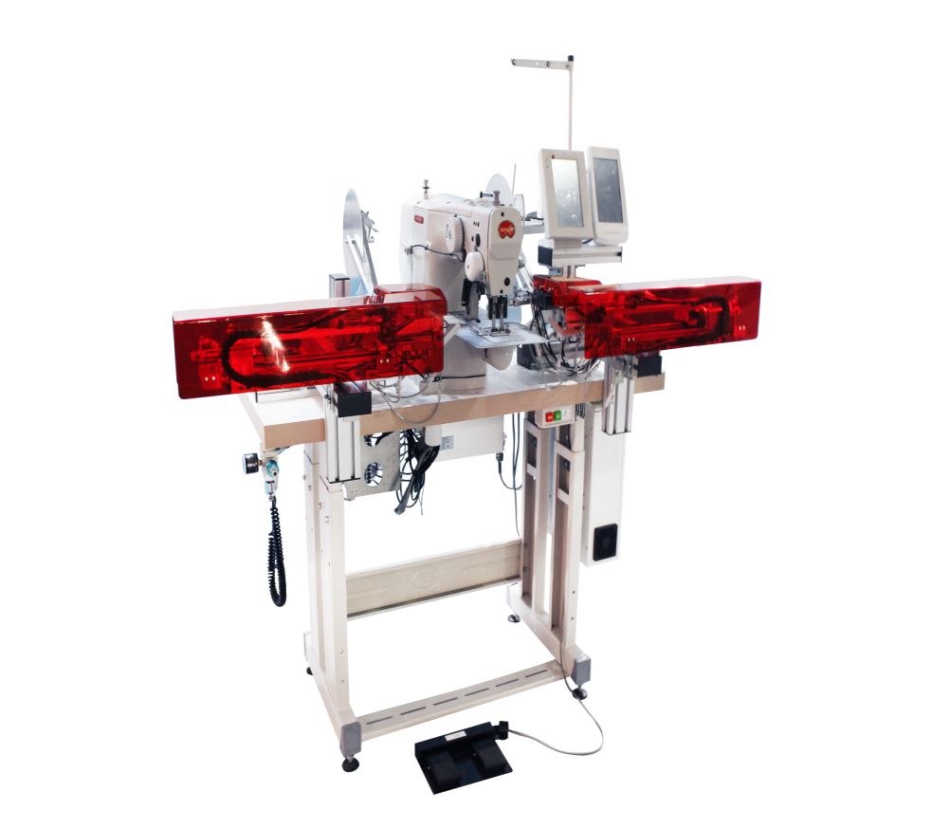
1
6
5
7
8

- Sewing machine head
- Clipping device
- Care label operation panel
- Sewing panel control
- Power switch
- Care label electric control box
- Sewing machine electric control box
- Pedal switch

- Transportation and installation

2.1 Lift and transportation
The machine must be packaged before the shipping. When lifting, check that the load capacity of the truck's insert can support the weight of the machine.
When the machine is placed in trucks and vans, ensure that there are fixed by ropes or belts.
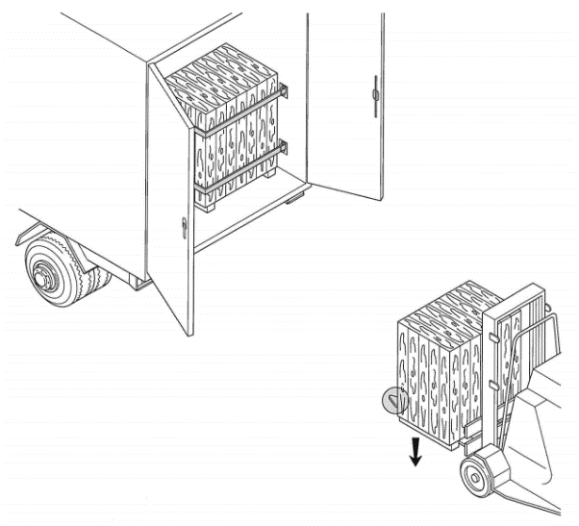
Figure 2.1 Transportation sketch

2.2 Loading and unloading
When unloading, ensure that the forklift's insert can withstand the full weight of the machine.
Check the machine for obvious damage during transport when removing the package. If it is damaged, do not use the machine and contact the manufacturer. Place the machine on a flat surface and do not expose it to the outdoors..
2.3 installation
Note: The machine must only be installed by a professional.
The manufacturer is not responsible for any property or personal injury caused by improper installation of the machine. These installation errors are mainly due to non-compliance with the instructions and failure to meet the main part of the connection requirements.
 If the machine is mounted on a suspended surface, check that the surface can withstand the weight of the machine。
There may be no flammable or explosive materials or objects in the area where the machine is located.。
Mandatory 0.5 m space must be left around the machine to operate and maintenance machine.
The machine must be placed on a hard and flat surface Turn the foot nut "A" (Fig. 2.2) to adjust the height.
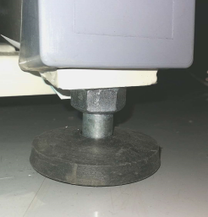
Fig. 2.2 foot nut
A

In order to make transportation more convenient, the movable part of the machine is tied and fixed by a tie.
Please check before use:
- Straight-line cylinders on both sides, fixed by a cable tie (Fig. 2.3), and the cable tie should be removed before use；
- The pedal is fixed by a cable tie (Fig. 2.4). Before use, remove the cable tie and place the pedal on the ground for convenient operation.；
- Two display screens (Fig. 2.5), remove the cable ties before use；
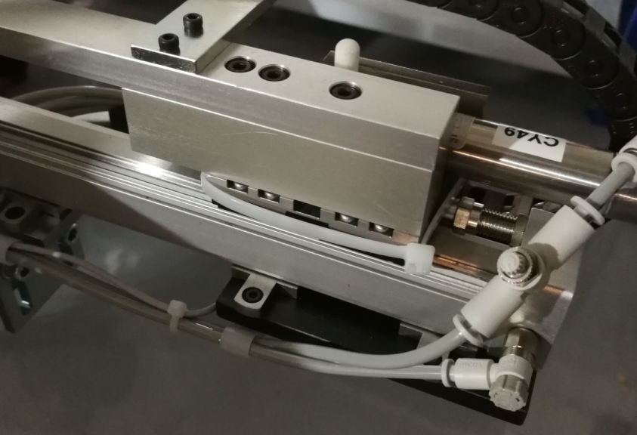
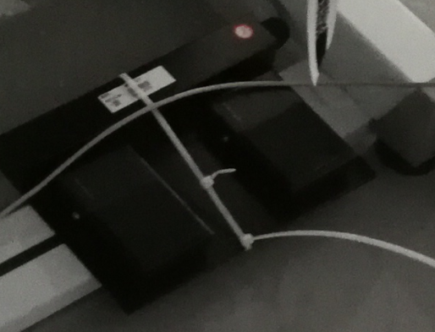
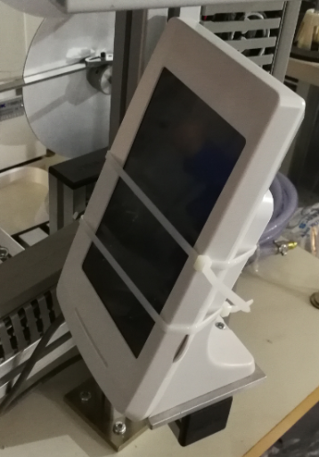
Fig.2.3 Straight-line cylinders tied and fixed
Fig2.4 The pedal is fixed by a cable tie
Fig2.5 screen fixed by a cable tie
Cable tie
Cable Tie
Cable tie

3. Preparation before sewing

When the machine is initially installed in the factory, the following adjustments are required to ensure safe operation and sewing effect：

- When the air source and power supply are not turned on, manually push the straight line clamping cylinders on both sides to the presser foot of the machine head to Check if the label clips on both sides interfere with each other (as shown in Figure 3.1), if there is interference, it must be adjusted by referring to Chapter 6 of this manual. It is not possible to connect the power in the presence of interference. If there is no interference, proceed to the next step；

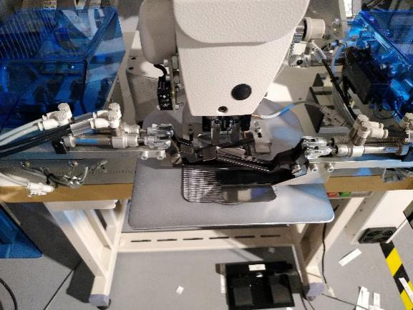
Figure 3.1 Checking whether the label clamp interferes

- Turn on the power switch and the air supply main switch to adjust the air pressure to 0.5MPa (5 standard atmospheres)；
- Wait for the head operation panel to start, enter the work interface, and then check whether the pattern displayed on the head control panel is a care label pattern.；
- Wait for the care label operation panel to start entering the work interface, then enter the sewing interface and wait for sewing。

4. Preparation of sewing pattern

The machine uses the bartacker head to sew the care label. This manual uses the Jack bartacker 19006BS-D (touch screen) that is equipped with this machine as an example to introduce how to prepare the pattern for the care label.
4.1 Enter the pattern editing interface
1）After startup, do not perform any operation, enter the main interface（as the picture shows 4.1），Click the System Settings button in the red circle to enter the System Settings screen.（as the picture shows 4.2）
2）In the system setting interface, click the pattern editing button in the red circle in the figure to enter the pattern editing confirmation interface.（As shown in pic. 4.3）
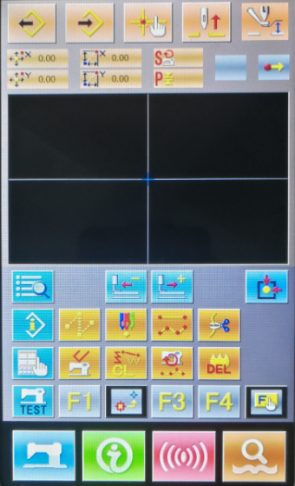
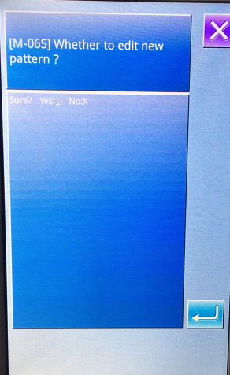
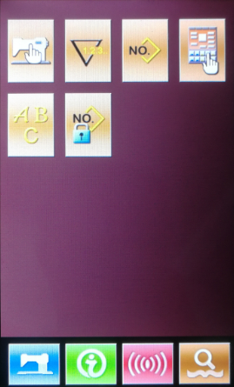
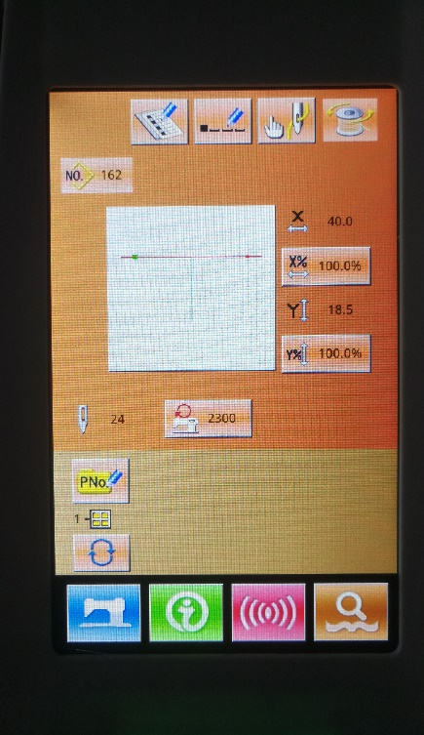
3) After confirmation, enter the pattern editing interface.（As shown in pic 4.4）
1
2
3
4
Fig.4.4 Pattern editing interface

Fig.4.3 Pattern editing enters the world

Fig.4.2 System settings interface
Fig.4.1 Start the main interface

4.2 Pattern editing set the second home
1）Feeding：in the pattern editing interface（as show pic 4.4） Click the feeding button in the red circle on the 1st Pic，Enter the confirmation screen and click Ok，Enter the confirmation screen and click OK（as pic. 4.5）。
2）Select coordinate point：Through the editing interface (as show pic4.5) in tirst Arrow button in no.1 red circle，The coordinates of feeding in the no.2 red circle（0,18），click OK in the no.3 red circle to complete the first feeding coordinate.
3）Set the second home coordinate: Click the specific function button in the no.2 red circle of the pattern editing interface to enter the function list.（Pic.4.6），Click the “Second Origin” function in the no.1 red circle, and then click the “Select” button in the no.2 red circle to enter the second origin editing interface, select the “OK”, and then enter into the pattern editing interface.

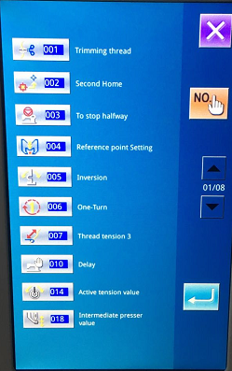
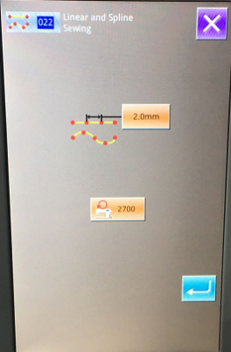
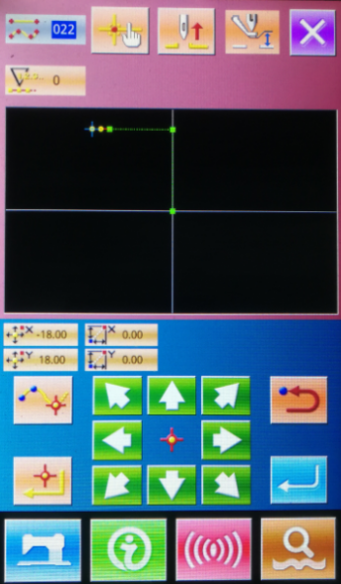
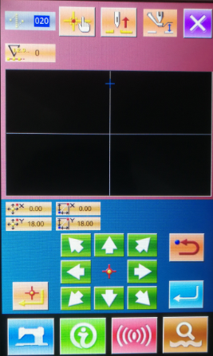
1
2
1
2
2
1
3

Pic.4.8 sewing parameter interface
Pic.4.6 Function list interface
Pic,4.5 feeding option
Pic. 4.7 Sewing parameter interface
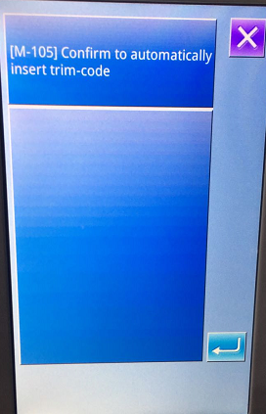
1
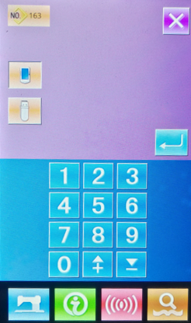
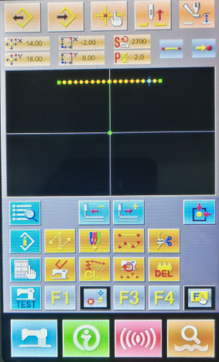
1

Pic 4.11 automatically inserts the trimming interface
Pic.4.10 Output interface
Pic. 4.9 Sewing parameter interface
boundary面

4.3 Pattern editing setting stitch

1） In the pattern editing interface（Pic 4.4）Click the "Feeding" button in the no.1 red circle. Follow the above steps to set the new feeding point coordinates to（14,18）.
2） In the pattern editing interface（pic 4.4）click "Ordinary sewing" button in the no. 3 red circle, enter the sewing parameter setting interface （pic 4.7），click the number in the no.1 red circle, enter the setting stitch distance interface, and input the required stitch length.（If you use the default value of 2mm, you do not have to enter the setting）, click OK to return to the sewing parameter setting interface, click the “OK” button in the no.2 red circle to enter the sewing editing interface (Pic. 4.8), use the arrow keys to determine the coordinate point（18,18），Click the "OK" button, the same reason, set the next sewing point（-18,18），and the next one（-16,18）.
3）In the pattern editing interface (Figure 4.4) click the “Output” button in the no.4 red circle to enter the output interface (as shown in the figure.4.10），Enter the number as the pattern name, note that the name cannot be repeated with the existing pattern name. It is recommended to choose a larger number, such as 161, click the "OK" button in the no.1 red circle to complete the naming，then the automatic insertion trimming interface will pop up (Figure 4.11), click the “OK” button to complete the editing of the new pattern.

5. Care label control system
5.1 Sewing data input interface
The sewing data input interface is shown in the right figure. For detailed function description, please refer to the function key description table.
A
C
D
E
F
G
H
I
J
B
Sewing data input interface

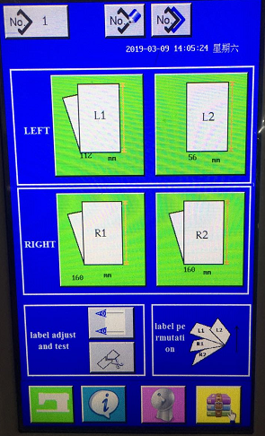

Function Description：
Serial number | Function | Detail
A | Pattern browsing | Can browse, select and delete patterns
B | New Pattern | Can create 99 new patterns
C | Pattern copy | Can copy patterns
D | L1,label settings | The label parameter setting of the first line L1 on the left side under the current pattern number
E | L2,label settings | The label parameter setting of the second line L2 on the left side under the current pattern number
F | R1,label settings | The label parameter setting of the first row R1 on the right side under the current pattern number
G | R2,label settings | Label parameter setting of the second row R2 on the right side under the current pattern number
H | Adjustment | Can adjust the position of the label and adjust the fiber parameters
I | feeding test | Pattern parameter verification of L1, L2, R1, and R2 can be achieved by feeding labels
J | Label arrangement | Display label up and down order

5.2 Sewing interface
Press on the sewing data input interface.  Enter the sewing interface as shown on the right. Press again to return to the sewing data.
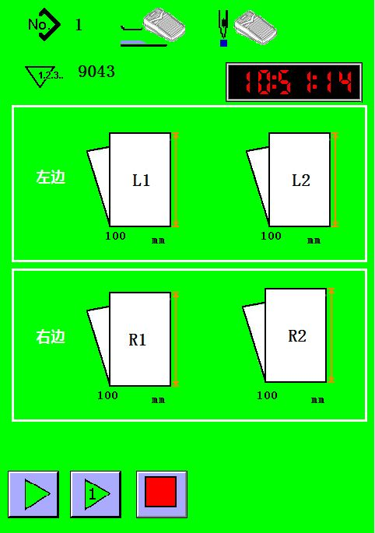
J
A
B
C
D
E
F
G
H
I
K
L
Sewing interface

Function Description：
Serial Number | Function | Detail
A | Pattern number | Display current pattern number
B | Presser pedal  detection | Presser pedal detection Show if the presser foot pedal can be used (cannot be used as automatic presser, can be modified in the machine parameter interface)
C | Sewing pedal detection | Show if the sewing pedal can be used (cannot be used for automatic sewing, can be modified in the machine parameter interface)
D | Sewing count | Display sewing count (can be cleared in the sewing count interface)
E | Time | Show current time
F | L1,Label length | First line on the left L1 label length
G | L2,Label length | Second line on the leftL2 label length
H | R1,Label length | First line on the rightR1 label length
I | R2,Label length | Second line on the rightR2 label length
J | Start up | Press the button to enter the continuous sewing state, press this button to switch to continuous sewing state when the machine is started once.。
K | Start once | Press the button to enter the single sewing state, press this button to switch to the single sewing state when the machine is in continuous state, Stop when the sewing ends.
L | Stop | Stop the action and reset immediately during the “Repeat Run” or “Start Once” process.

5.3 Pattern Browsing
Press the right icon 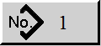 to enter the pattern browsing interface (as shown below). For detailed function descriptions, see the function key description table.
No. | Function | Content
A | Pattern Number | Displays the current pattern number
B | Selection Area | Display the patterns that can be selected
C | Exit | Exit the pattern browsing selection and keep the pattern selection before entering the interface.
D | Confirm | Confirm the new selected pattern
E | Page up | Page up
F | Page down | Page down
G | Delete | Delete selected patterns (cannot delete all patterns, must retain at least one pattern)
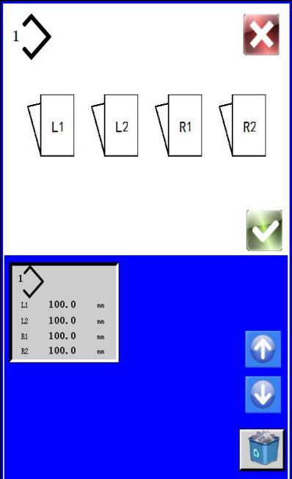
Function Description：
A
B
C
D
E
F
G
Pattern Browsing Interface
A
C
B
E
F
G
D

5.4 Design new pattern
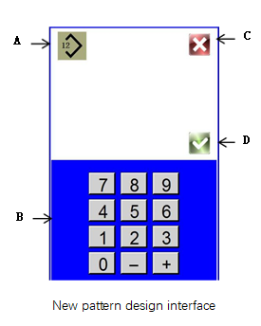
Press the right icon . Enter the new pattern design interface (as shown below). For detailed function descriptions, you can see the function key description table.
No. | Function | Content
A | Pattern Number | Display the number of the new pattern you need to create
B | Input Area | Display pattern number keyboard input area
C | Exit | If you exit new pattern design, no new pattern will be created
D | Confirm | Confirm that the new pattern needs to be created. If the pattern already exists, this button will not be displayed.
Function Description：

5.5 Pattern copy
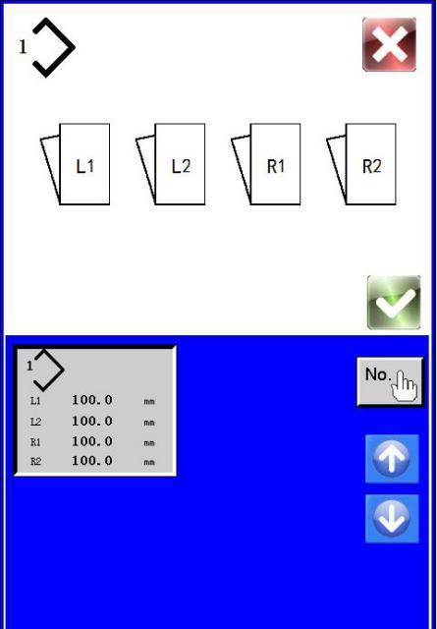
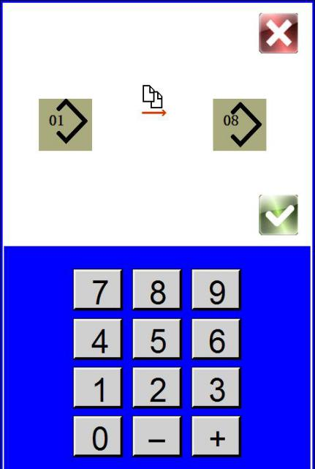
Press the right icon  enter the pattern copy interface(as show on the right side).For detailed function descriptions, you can
A
C
B
D
E
F
G
Pattern copy interface 1
H
J
L
K
Pattern copy interface 2
C
D
E
F
G
I
J
K
L

see the function key description table.
Function Description：
No. | Function | Content
A | Pattern Number | Display the copied pattern number
B | Selection Area | Display the copied pattern number selection area
C | Exit | If you exit pattern copy, the pattern will not be copied
D | Confirm | Confirm the selected pattern and it will be copied
E | Copy | Enter the pattern copy interface 2
F | Page Up | Page Up
G | Page Down | Page Down
H | Copied pattern number | Display the copied pattern number
I | Input Area | Input the copied pattern number
J | Exit | Exit the pattern copy
K | Copy pattern number | Display the copied pattern number
L | Confirm | Confirm the pattern of copying H to K

5.6 Label Parameter Setting
Press the right icon 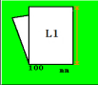，enter the corresponding label parameter setting interface, two trademarks on the left and right side, click the corresponding button to enter the corresponding label parameter setting interface (as shown in the right figure).At the same time, the button screen will change according to the functions of “Enable” and “Fold”. For detailed function description, see the function key description table.
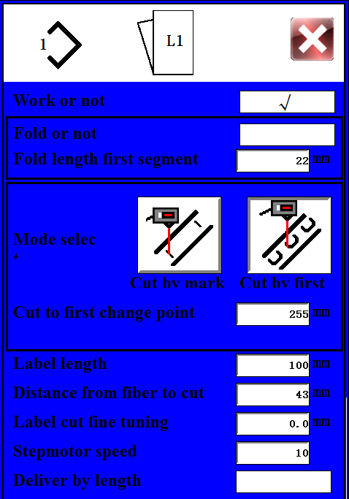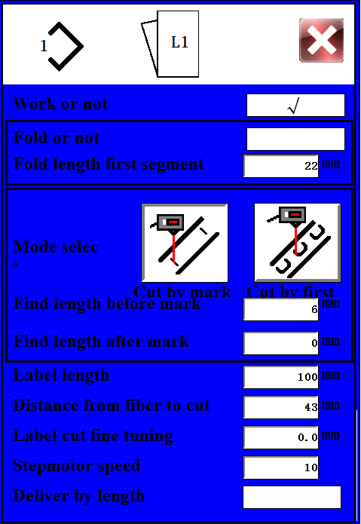
A
B
C
D
E
F
H
G
I
J
K
L
M
Label parameter setting

Function Description：
No. | Function | Content
A | Whether it works | It determines whether the label works. If it works, the label can be transferred and the opposite will not. The 4 labels overlap as shown on the right figure.
B | Whether it is folded in half | It determines whether the label is folded in half. If the label can be folded in half, the label cannot be transferred and the opposite will not.
C | First delivery length | The folding delivery label is divided into two sections. The first section determines whether the front end of the folding is flush, which is generally set as 22-24mm.  As shown in the figure below, when the lower part is too short, parameters need to be increased. When the bottom is too long，you need to reduce the parameters.
D | Mode  Selection | Select mark line mode or first discoloration point detection
E | Label line before marking the length of solid color | Take the black line on a white background as an example, there will be a blank area before and after the black marker line, and the length of this area is required to be input, generally 6mm, as shown in the figure below
F | Label line before marking the length of solid color | Take the black line on a white background as an example, there will be a blank area before and after the black marker line, and the length of this area is required to be input, generally 6mm, as shown in the figure below
G | Label length | Enter label length. Enter the length between the two label lines as shown in the figure below.
H | The distance from the fiber point to the edge | Optical fiber point to the knife edge distance, generally 43mm, related to the mechanical structure of the machine itself, generally not adjusted.
I | Label incision fine adjustment | Label notch trimming. When the black marker line is too much, set this value to -1 if it is 1mm too much. When there are not enough black lines, set this value to 1 if 1mm is missing. As shown in the figure below.
J | Stepper motor speed | Stepper motor speed gear, a total of 10 files, respectively 1-10.
K | Send labels only by label length | When this option is selected, it will not be sent according to the marking line. The more the number of labels is sent, the higher the offset error is. This option is generally not selected.
L | The length from the tangent point  to the first discoloration point | It is suitable for the detection method without marking lines, taking the black text on a white background as an example, the distance from the cutting point to the point of the first color change.
M | Exist | Exit settings
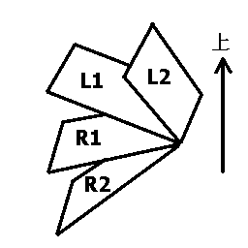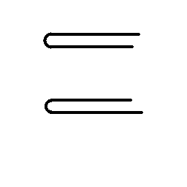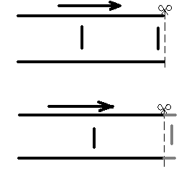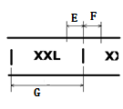
Parameter G、E and F
Parameter C needs to be increased
Parameter C needs to be reduced
Parameter I needs to be reduced

Parameter I needs to be increased

Labels overlap
参数I需要减小

5.7 label position adjustment
Press 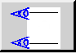 to enter the label position adjustment mode to adjust the label (as shown in figure below). See function key description table for detailed function description.
function description:
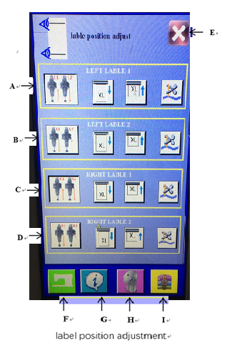

Name | Function | Contents
A | First label on the left side | First label area on the left side.
B | Second label on the left side | Second label area on the left side.
C | First label on the right side | First label area on the right side.
D | Second label on the right side | Second label area on the right side.
E | Exit | Exit the label position adjustment mode.
F | Enabling | Enable corresponding label, lift cylinder below, make label move
G | Label comes out | Keep press corresponding label to make label come out, it stops when not pressed.
H | Label retracts | Keep press corresponding label to make label retract, it stops when not pressed.
I | Knife | It moves when press corresponding knife，and it resets when press it again.

5.8 Label feeding test mode

Press  to enter label feeding test mode to do test of label feeding (as shown in figure below). See function key description table for detailed function description.
function description:
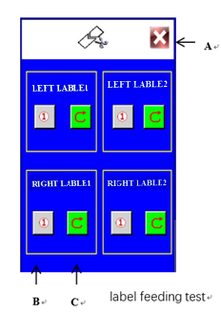
Name | Function | Contents
A | Exit | Exit label feeding test mode.
B | Single  label feeding | Press the corresponding label to feed the label once (no fold), which can be used to confirm the corresponding label parameters.
C | Repetitive label feeding | - Press the corresponding label to feed the label repeatedly（ no fold ）.

5.9 Program information interface
In the sewing data input interface, press  to enter program information interface as shown in the figure below, and then press again to return to sewing data input interface. The program information interface displays the program version.
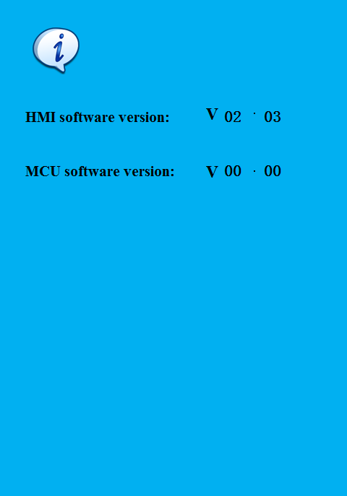
Program version

5. 10 pattern parameter file transfer
In sewing data input interface, press  to enter pattern parameter file transfer as shown in the figure below, and then press again to return to sewing data input interface. See function key description table for detailed function description.
Note: insert usb flash drive before operation.
Name | Function | Contents
A | File selection | Select standard file.bin.
B | File selection | Select userfile.bin.
C | File selection | Select statussfile.bin.
D | Transfer direction selection | Sets up transferring files from the usb flash drive to panel.
E | Transfer direction selection | Sets up transferring files from panel to the usb flash drive.
F | Execution | Execute based on file selection and transfer direction selection.Follow the prompts to Execute subsequent movements.
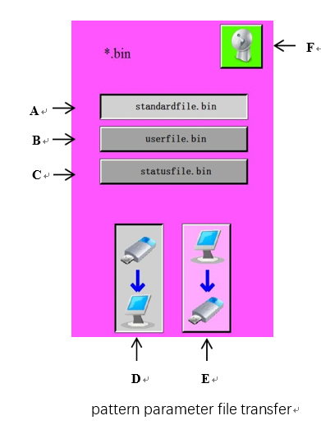
Function description:
5.11 Setting interface
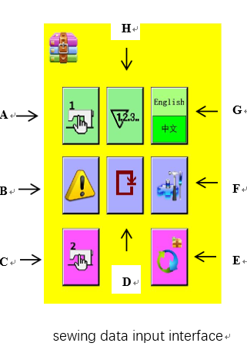
In sewing data input interface, press  to enter setting interface as shown in the figure below, and then press again to return to sewing data input interface. See function key description table for detailed function description.
Function description:
Name | Function | Contents
A | Machine parameter 1 setting | Set common machine parameters, such as delay, malfunction and pedal setting.
B | Malfunction history | Display malfunction history.
C | Machine parameter 2 setting | Set not commonly used machine parameters, which requires password to enter.
D | Single step operation | Test single step operation，which requires password to enter.
E | Parameter reset | Parameter reset，which requires password to enter.
F | Diagnostic mode | Enter input/output diagnostic mode.
G | Switch between Chinese and English | Language switching between Chinese and English.
H | Count | Display count information.

5.12 Machine parameter 1 setting
Press  to enter machine parameter 1 setting interface, there are 4 pages in total. Page turning can be done by up and down page, and press the exit key to exit, as shown in the figure below. See function key description table for detailed function description.
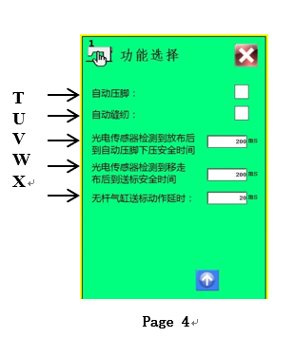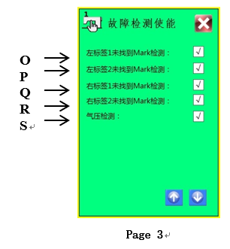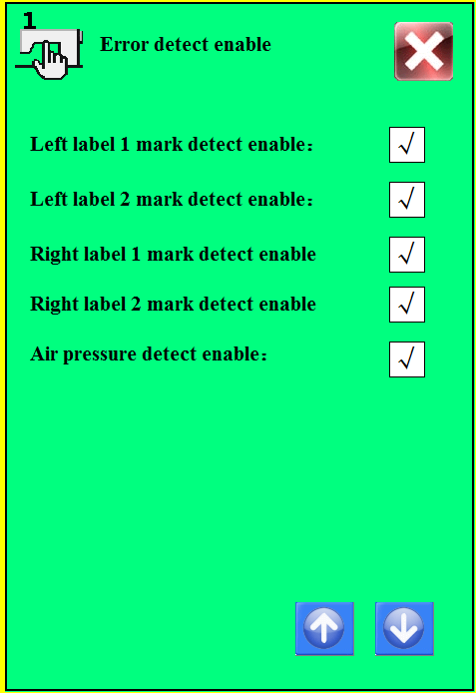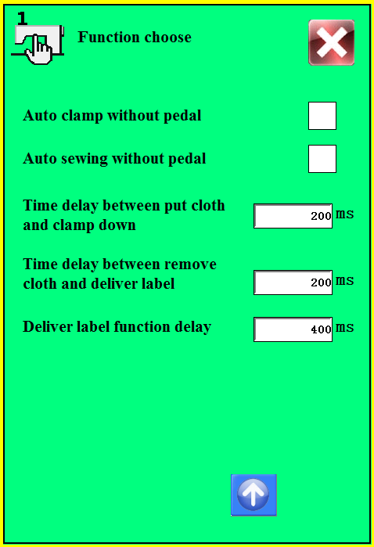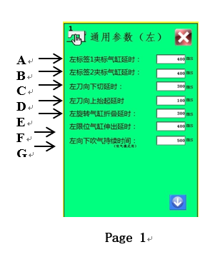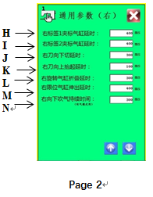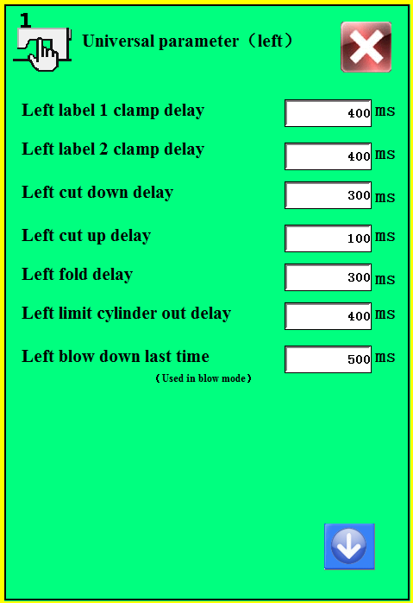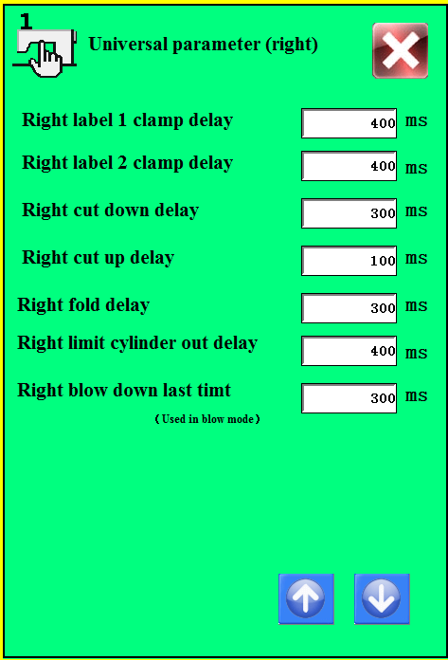
Function description:
Name | Function | Contents
A | Left label 1 label clamping cylinder delay | Left label 1 label clamping cylinder delay, the default time is 400ms.
B | Left label 2 label clamping cylinder delay | Left label 2 label clamping cylinder delay, the default time is 400ms.
C | The left knife delays to cut downwards | The left knife delays to cut downwards, the default time is 300ms.
D | The left knife delays to lift upwards | The left knife delays to lift upwards, the default time is 100ms.
E | The left rotating cylinder delays to fold | The left rotating cylinder delays to fold, the default time is 300ms.
F | The left rotating cylinder delays to stretch | The left rotating cylinder delays to stretch, the default time is 400ms.
G | It delays to blow left downwards | It delays to blow left downwards, the default time is 500ms.
H | Right label 1 label clamping cylinder delay | Right label 1 label clamping cylinder delay, the default time is 400ms.
I | Right label 1 label clamping cylinder delay | Right label 2 label clamping cylinder delay, the default time is 400ms.
J | The right knife delays to cut downwards | The right knife delays to cut downwards, the default time is 300ms.
K | The right knife delays to lift upwards | The right knife delays to lift upwards, the default time is 100ms.
L | The right rotating cylinder delays to fold | The right rotating cylinder delays to fold, the default time is 300ms.
M | The right rotating cylinder delays to stretch | The right rotating cylinder delays to stretch, the default time is 400ms.
N | It delays to blow right downwards | It delays to blow right downwards, the default time is 500ms.
O | Left label 1 fails to track label thread detection | Left label 1 fails to track label thread detection, it’s switched on by default.
P | Left label 2 fails to track label thread detection | Left label 2 fails to track label thread detection, it’s switched on by default.
Q | Right label 1 fails to track label thread detection | Right label 1 fails to track label thread detection, it’s switched on by default.
R | Right label 2 fails to track label thread detection | Right label 2 fails to track label thread detection, it’s switched on by default.
S | Pressure detection | Detection for pressure malfunction, it’s switched on by default.
T | Automatic presser foot | Automatic press presser foot when detecting fabric placed, it’s switched off by default.
U | Automatic sewing | It automatically sews when press presser foot, it’s switched off by default.
V | The safe time from the photoelectric sensor detects fabric placed and automatic presser foot pressing | It delays after the photoelectric sensor detects fabric placed and automatic presser foot pressing, the default time is 200ms.
W | The safe time from the photoelectric sensor detects fabric taken away and label feeding | After sewing, it delays after the photoelectric sensor detects fabric taken away and label feeding, the default time is 200ms.
X | Rodless cylinder delays to feed label | Rodless cylinder delays to feed label the default time is 400ms.

5.13 Alarm history interface
Press  to enter Alarm history interface
See function key description table for detailed function description.
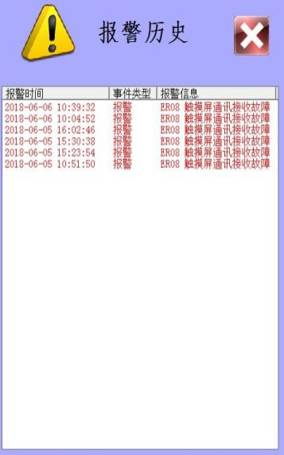
A→
←B
Function description:
Name | Function | Contents
A | Alarm history display | Display alarm history
B | Exit | Exit alarm history display

5.14 Machine parameter 2 setting
Press , and input password”21’’ to enter Machine parameter 2 setting interface as shown in the figure below. See function key description table for detailed function description.

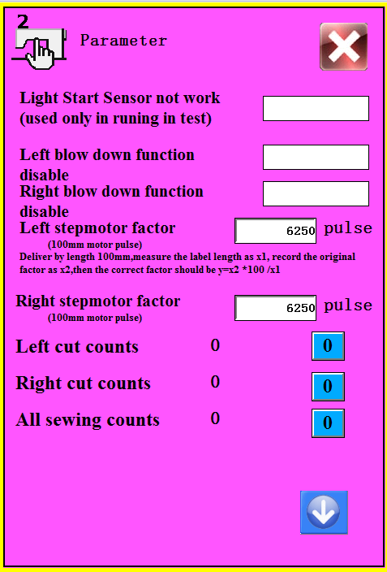
A
C
B
Page 1 function description
I
D
E
F
G
H
J
Page 1 function description:
Name | Function | Contents
A | Photoelectric sensor non effective | For durable run-in, it’s switched off by default.
B | Blow left downwards function off | For turning off blow left downwards function, it’s switched off by default.
C | Blow right downwards function off | For turning off blow right downwards function, it’s switched off by default.
D | Left stepping motor coefficient | Set left stepping motor coefficient, the default value is 6250.
E | Right stepping motor coefficient | Set right stepping motor coefficient, the default value is 6250.
F | Left knife operation times | Record left knife operation times, it needs password when zero cleaning.
G | Right knife operation times | Record right knife operation times, it needs password when zero cleaning.
H | Total sewing times | Record total sewing times, it needs password when zero cleaning.
I | Exit | Exit machine parameter 2 setting
J | Next page | Enter into page 2 setting

Page 2 function description:
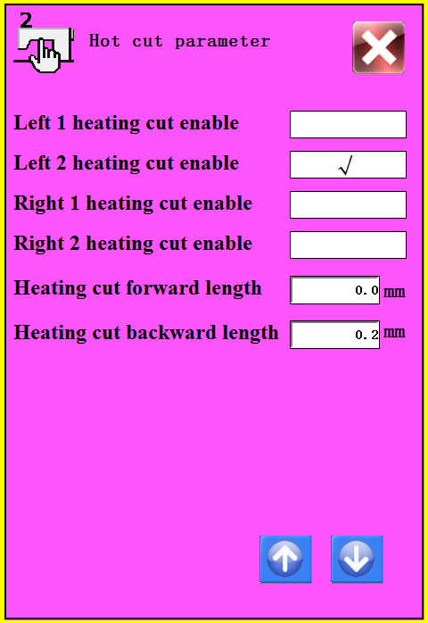
K→
L→
M→
N→
O→
P→

←Q

K | Left 1 knife heated function on | For factory data reset，suitable for knife heated machine.
L | Left 2 knife heated function on | For factory data reset，suitable for knife heated machine.
M | Right 1 knife heated function on | For factory data reset，suitable for knife heated machine.
N | Right 2 knife heated function on | For factory data reset，suitable for knife heated machine.
O | Heated knife going forward distance | Set knife heated parameter and going forward distance
P | Heated knife going backward distance | Set knife heated parameter and going backward distance
Q | Exit | Exit machine parameter 2 setting
R | Previous page | Back to page 1 setting

5.15 Factory data reset

Press  and input password”110119120” to reset factory data

5.16 Diagnostic mode
Press  enter Diagnostic mode as shown in the figure below. See function key description table for detailed function description.
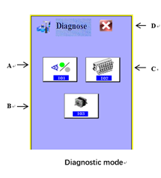
Page 1 function description:
Name | Function | Contents
A | Input | Enter input port testing interface
B | Motor | Enter stepper motor testing interface
C | Output | Enter output port testing interface
D | Exit | Exit diagnostic mode
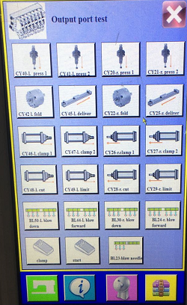
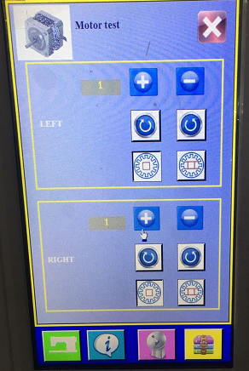
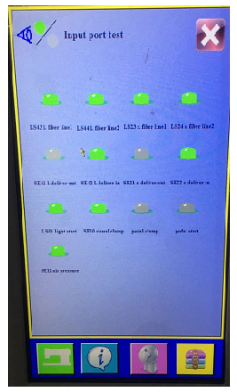
Input port testing Stepper motor testing Output port testing

5.17 Language setting
Press 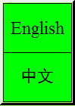 then Chinese and English can be switched.

5.18 Count information display
Press 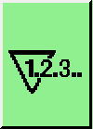 and enter Count information display as shown in the picture below.

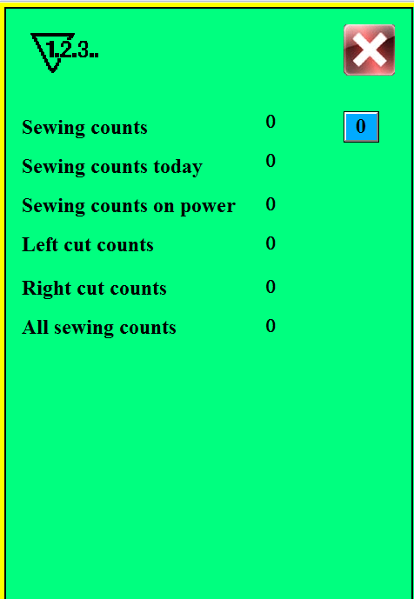
Count information display

6. Adjustment
6.1 Process of replace washing label and machine equipment setting
When replacing washing label and technology, the program and equipment should be debugged. This manual explains the debugging of up to 4 trademarks.
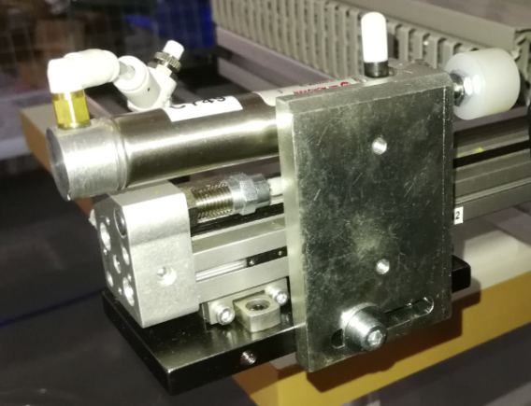
- debug the alignment between the two washing marks on the left. When both washing marks are not fold, alignment between the two marks mainly includes left alignment, right alignment and center alignment, which is actually to adjust the distance X1 on the left side of the washing label (as shown in figure 6.1.1). The adjustment of the parameter is mainly achieved by moving the position of the left secondary cylinder on the fixed frame, as shown in fig. 6.1.2, loosen screw A, then move the fixed seat to the left and therefore the left washing label 1 shown in fig. 6.1.1 moves to the left, same as adjustment towards right.
fig. 6.1.1 left washing label alignment fig.
6.1.2 left secondary cylinder adjustment

A
Left secondary cylinder

Left 1

Left 2
X1

2) when the trademark is folded, as shown in fig. 6.1.3, if the two cutting edges of the washing label are not aligned after folding, the length of label can be folded by adjusting the distance Y1 between the two cutting edges (refer to label parameter setting of 5.6), and the factory default parameter of folded length is 24mm.
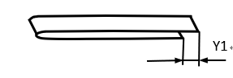
fig. 6.1.3 left washing label alignment
- adjust the left side distance of the two right washing marks by adjusting screw B in fig. 6.1.4
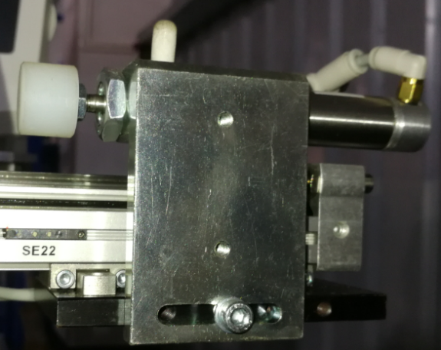
fig. 6.1.4 right washing label alignment

Right secondary cylinder

B
4) after washing labels on both sides are adjusted in place, then adjust Z1 parameters between washing labels on the left and the right (as shown in fig. 6.1.5), loosen the nuts C and D of the oil buffer in fig. 6.1.6 and 6.1.7, then rotate and adjust the position of the oil buffer to close, and then lock the nuts C and D. It is recommended to adjust one side first, and then adjust the other side after the adjustment first time fails.
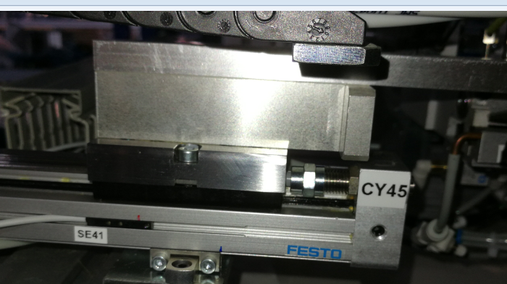
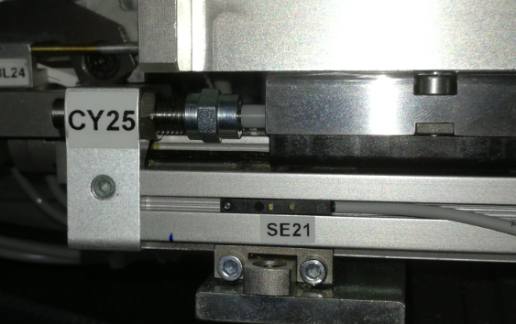
5) finally, adjust the alignment of the cutting edges of washing labels on both sides. Loosen screw E in fig. 12.8 on the left side and follow the arrow direction in fig 12.8 and then lock E, same as adjustment of the right side. Or just adjust only one side to make alignment.
fig. 6.1.5 left washing label alignment
alignmentalignment
fig.6.1.6 left washing label alignment adjustment
C
Oil buffer
fig.6.1.7 right washing label alignment adjustment

Oil buffer

D

Right washing label

Left washing label 2

Z1
K1
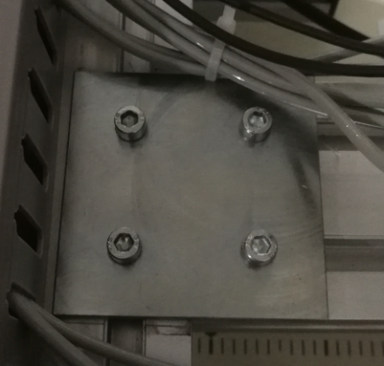
E
fig.6.1.8 adjust the alignment of the cutting edges of washing labels

6) when washing label is folded, the folding deviation may occur, as shown in fig. 6.1.9. At this time, it is necessary to adjust label feeding device and clamp feeding device to perpendicular, as shown in fig. 6.1.10. The following is detailed adjustment:
J
fig.6.1.9 adjust washing label on fig.6.1.10 position
right side to make alignment.

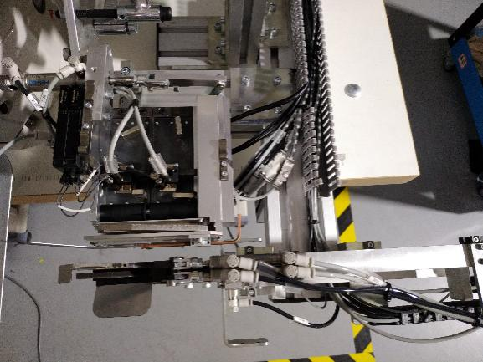
label feeding device

perpendicular
clamp feeding device

Firstly, observe whether clamp feeding device and the presser foot are parallel, as shown in fig. 6.1.11. If it is not parallel, release screw F shown as fig. 6.1.12, and adjust clamp feeding device’s position to parallel presser foot and then lock screw F.
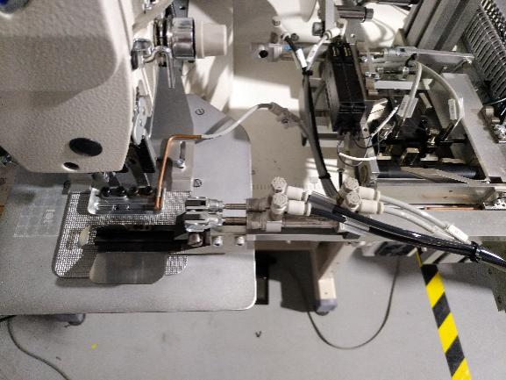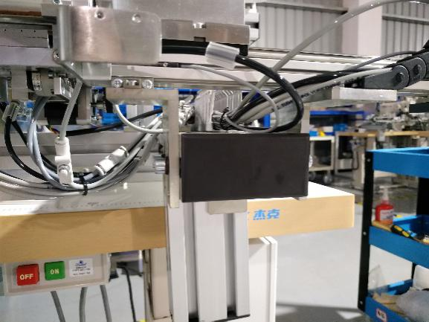
F
F
clamp feeding device
parallel
presser foot
fig. 6.1.12 clamp feeding device fixes screw

fig. 6.1.11 presser foot and clamp feeding device

Then measure whether label feeding device and clamp feeding device are perpendicular (as shown in fig. 6.1.10). If not, continue to adjust the position of label feeding device as shown in fig. 6.1.13, loosen screw G and adjust label feeding device and clamp feeding device to be perpendicular and then tighten screw G.
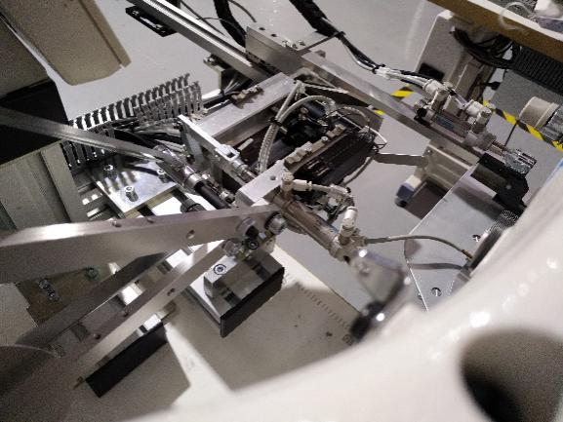
label feeding device
G
clamp feeding device
perpendicular
fig. 6.1.13 adjust label feeding device

6.2 Photoelectric Sensors Adjustment

There is one photoelectric sensor, numbered LS01, located at the head.
Step 1: Turn Knob A to the picture as shown
Step 2: Adjust knob C to achieve the following effect: When no fabric is placed below, the indicator B is orange; when the fabric is placed below, the indicator B is off.
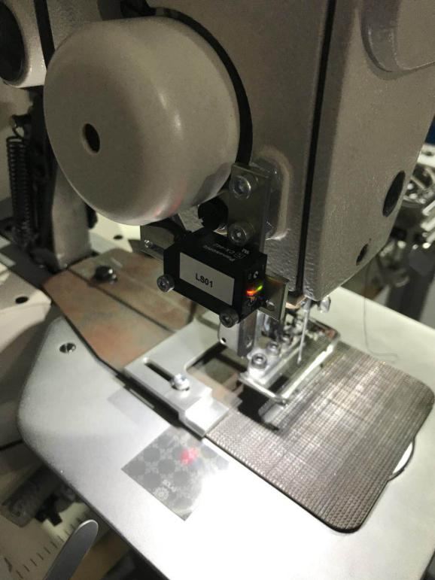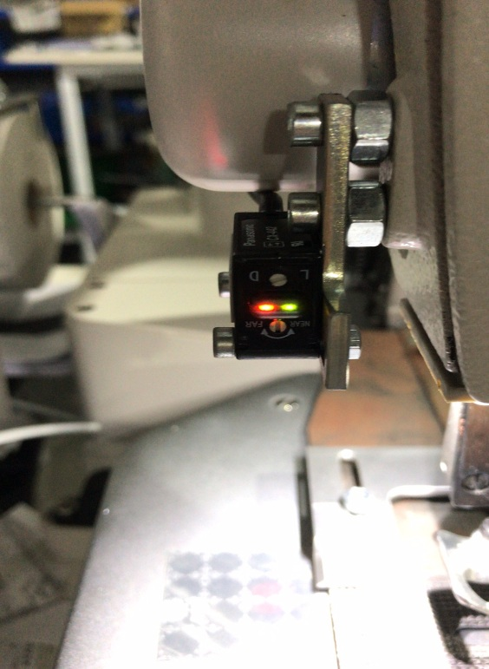
Knob A
Indicator B
Knob C

6.3 Optical Fiber Amplifier Adjustment
There are four optical fiber amplifier，numbered LS43、LS44、LS23、LS24, located at the label feeding device on two sides.
Note: The distance between the fabric and the fiber has a large influence on the value, so the fiber amplifier should be adjusted so that the label feeding plate is in the working position. Refer to “5.7 Label Position Adjustment” to enter the label position adjustment, press the ABCD button in “5.7 Label Position Adjustment”, and then adjust the corresponding fiber amplification according to the following steps.
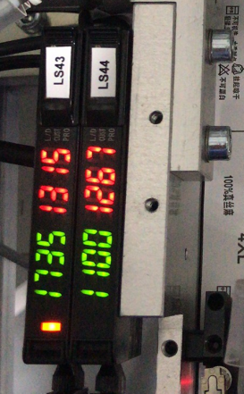
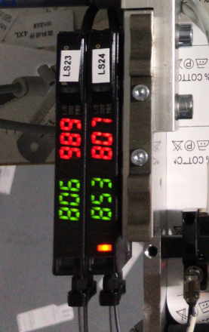
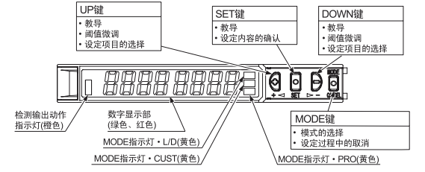
UP Key
◆Instruction
◆Threshold fine-tuning
◆Setting item selection

SET Key
◆Instruction
◆Setting item selection

DOWN Key
◆Instruction
◆Threshold fine-tuning
◆Setting item selection

Detection output action indicator (Orange)

Digital Display (Green,Red)

MODE Key
◆Mode selection
◆Cancellation during setup

MODE indicator PRO (Yellow)

MODE indicator CUST (Yellow)

MODE indicator L/D (Yellow)

1）Reset operation

Anti-interference settings

CUSTOM settings

Automatic
<Mode RUN>

Twinkling 3 times

Twinkling

Copy settings

Display adjustment settings

Copy settings

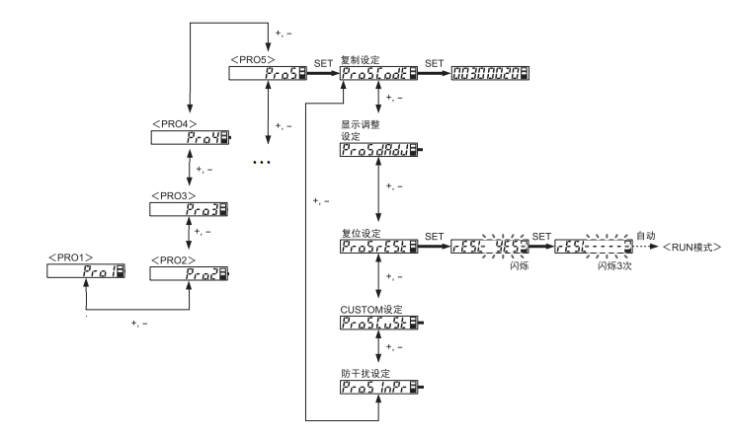

2）L-on/d-on Settings
When the label is black on white, it should be set to d-on; when it is white on black, it should be set to L-on.
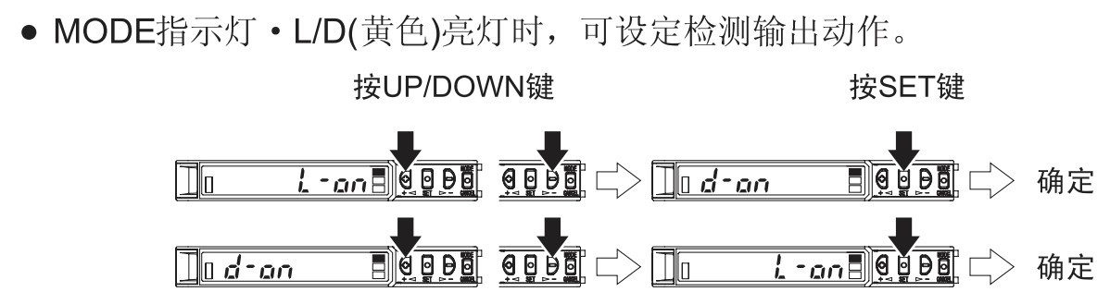
Determined

Determined

Press SET button

Press UP/DOWN button

●When L/D(Yellow) lighting, can set the detection output action

●MODE indicator

3）Setting the amount of light, generally setting the amount of light to be medium
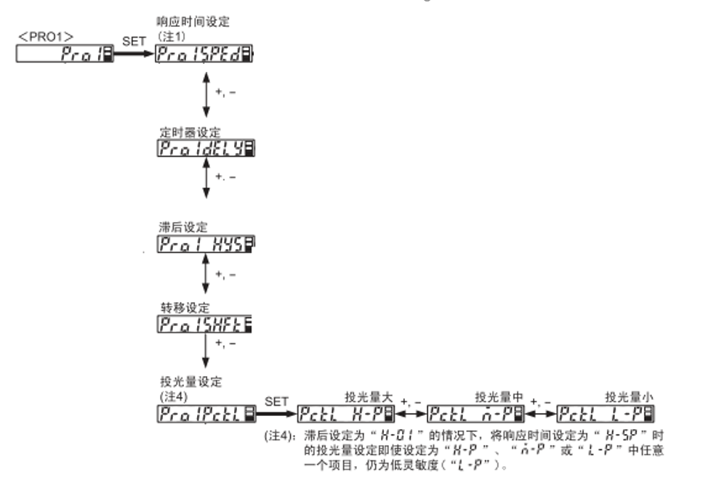
(Remark 4): When the Hysteresis is set to “H-01”, the Response time is set to “H-SP”, even if the light amount is set to anyone of the “H-P”, “n-P” or “L-P”, is still the low sensitivity (“L-P”).

Amount Medium

Amount Low

Amount High

Light amount setting
Remark 4

Response time setting

Transfer setting

Hysteresis setting

Timer setting

4）Threshold setting
Method 1：2 points Instruction, as shown below. Take the black text on the white label as an example, when the red dot of the fiber shines on the white background, press the first SET; when the red dot of the fiber shines on the black line, press the second SET. If “good” is displayed, the Instruction is successful.
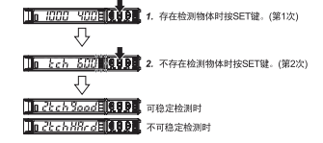
When is on Unstable detection
When is on Stable detection
- Press the SET button when there is an object detected (First time)

- Press the SET button when there is NOT an object detected (Second time)

Method 2: The fiber values for the white background and black lines can be recorded separately, and then the threshold is adjusted by pressing "+" or "-" to make it at the average of the two values.

6.4 Rodless Cylinder Sensor Adjustment
There are four rodless cylinder sensors，numbered SE41、SE42、SE21、SE22, located at the two sides of the two rodless cylinders

The adjustment effect is: when the rodless cylinder is at both ends, the corresponding detection sensor light is on.
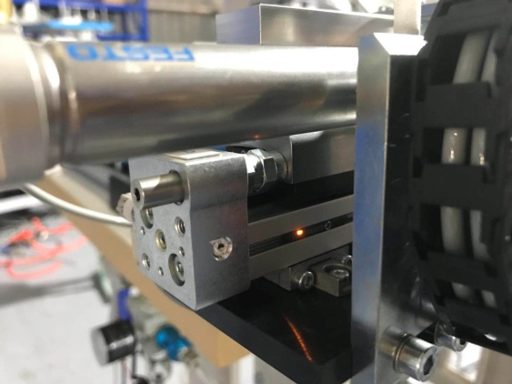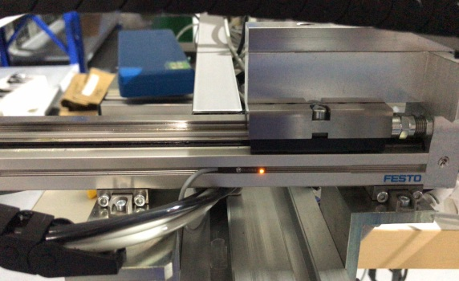
Sensor
Sensor
6.5 Proximity Switch Adjustment
There is one proximity switch，numbered SE10, located at the end of the machine head, covered by a tail hood.
When the presser foot moves, the detected object moves. Therefore, the detected object is detected to indicate the presser foot action.
Adjustment requirements: When the presser foot is raised, the indicator light is on; when the presser foot is pressed, the indicator light is off.
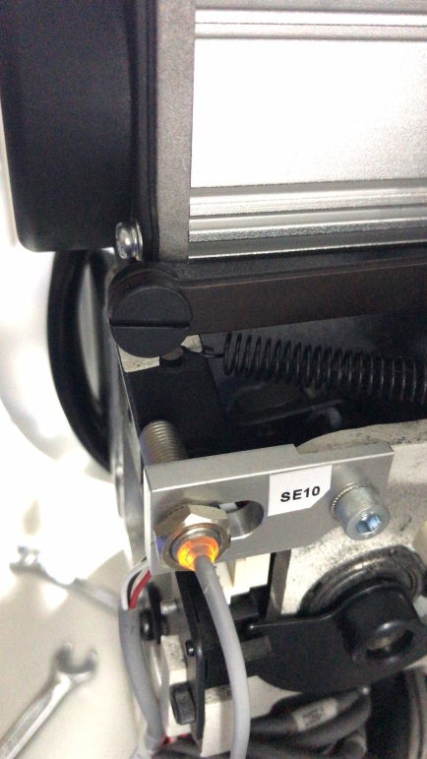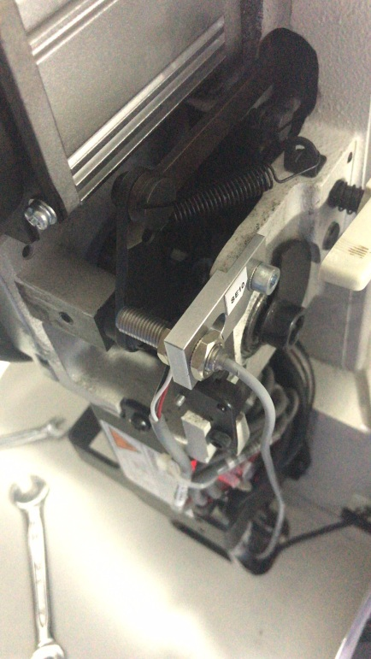
Detected object
Sensor
Indicator light
Detected object

Sensor

Indicator light

6.6 Air Pressure Detection Adjustment
There is one air pressure detector, located on the lower left side of the platen. The black arrow in the barometer is the Set pressure, and the green arrow is the Alarm indicating pressure

After the machine is connected to the air, pull out the Adjustment knob and turn the adjustment knob to set the air pressure to 0.5 MPa.
Open the glass cover of the barometer and turn the green arrow to set the Alarm indicating pressure to 0.4 MPa.
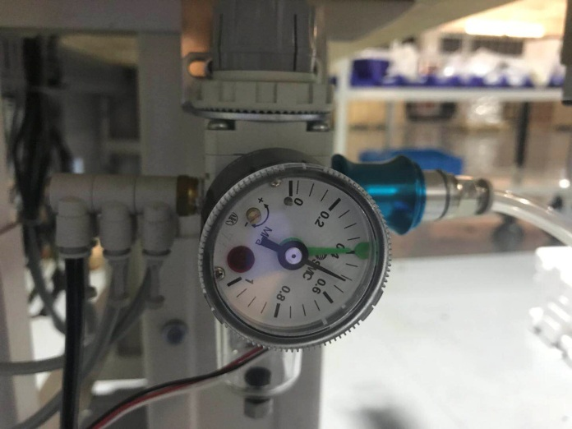
Adjustment knob
Alarm indicating pressure
Set pressure
6.7 Pressure Regulator Adjustment
Enter the diagnostic mode, respectively air the corresponding tube, and then adjust the corresponding air pressure. After the air pressure is adjusted, the nut should be locked.
The air pressure in the table below is for reference only, and the actual air pressure will vary depending on the actual commissioning.

Label | Air pressure
TB45 | 4bar
TS45 | 4bar
TB41 | 4bar
TB40 | 4bar
TB25 | 4bar
TS25 | 4bar
TB21 | 4bar
TB20 | 4bar
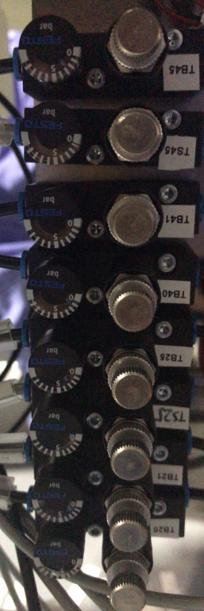

7. Maintenance



The power and air pressure sources must be disconnected when replacing machine parts, maintaining or disassembling the machine. Only professionals can do the following operations.
Motor cleaning
Clean the motor regularly with a gas nozzle.
Needle plate cleaning
Loosen the screws, clean the needle plate, and then restore the position
Lubrication
Check the surface level of the head lubricant regularly and fill it up with white oil if necessary.
Destroy the machine
If want to destroy the machine, separate the parts and send them to the appropriate collection point.

8. Fault Resolution
ER01 Left label 1 didn't find the label line
Cause | The label is used up; the label line is printed incorrectly; the label sending is invalid; the label parameter setting is incorrect; others.
Solution | Check the label and label line and please check if the label is sent correctly. If it is not correct, you can finely adjust it manually to clear the fault.

ER02 Left label 2 didn't find the label line
Cause | The label is used up; the label line is printed incorrectly; the label sending is invalid; the label parameter setting is incorrect; others.
Solution | Check the label and label line and please check if the label is sent correctly. If it is not correct, you can finely adjust it manually to clear the fault.

ER03 Right label 1 didn't find the label line
Cause | The label is used up; the label line is printed incorrectly; the label sending is invalid; the label parameter setting is incorrect; others.
Solution | Check the label and label line and please check if the label is sent correctly. If it is not correct, you can finely adjust it manually to clear the fault.

ER04 Right label 2 didn't find the label line
Cause | The label is used up; the label line is printed incorrectly; the label sending is invalid; the label parameter setting is incorrect; others.
Solution | Check the label and label line and please check if the label is sent correctly. If it is not correct, you can finely adjust it manually to clear the fault.

ER05 The head is not reset (the presser foot is not raised)
Cause | The head is not reset; the sensor SE10 is faulty or its wiring is faulty.
Solution | Please enter the sewing machine into the sewing mode or check the sensor SE10, self-recovery after troubleshooting.

ER06 Insufficient pressure
Cause | No air o air pressure detection sensor setting failure or wiring failure.
Solution | Please check the air pressure or air pressure detection settings and wiring, self-recovery after troubleshooting

ER07 Machine reset was unsuccessful
Cause | Rodless cylinder sensor SE22 and SE42 signal abnormalities
Solution | Please check if the rodless cylinder sensors SE22 and SE42 are abnormal, and they will self-recovery after troubleshooting

ER08 Touch screen communication reception failure
Cause | Touch screen communication reception failure
Solution | Please power off and check the communication line and restart

ER09 Control board communication reception failure
Cause | Control board communication reception failure
Solution | Please power off and check the communication line and restart

ER10 Remove items from the sewing table
Cause | There are items on the sewing table; or the sensor LS01 is abnormal.
Solution | Please remove the items on the sewing table or check if the photoelectric sensor LS01 is abnormal.

ER11 Please put a piece of fabric to sew
Cause | No fabric is placed; or sensor LS01 is abnormal
Solution | Please put a piece of fabric to sew, or check if the photoelectric sensor LS01 is abnormal.

ER12 The presser foot is not raised. The threading operation is in progress.
Cause | The presser foot is not raised. The threading operation is in progress.
Solution | End the threading, self-recovery after exiting the threading mode

9. Remaining list
In order to quickly and easily confirm the remaining part of the need, a Parts Manual is provided, which contains a list of parts, an exploded view and its serial number.

